Year 10 |  | Congruence | Non Calculator
Skills and Knowledge Assessed:  - Define congruence of plane shapes using transformations (ACMMG200)  - Develop the conditions for congruence of triangles (ACMMG201)  - Formulate proofs involving congruent triangles and angle properties (ACMMG243) |  |  | Name_________________
Section 1 Short Answer Section
Write all working and answers in the spaces provided on this test paper.
YOU WILL NEED A RULER, COMPASSES AND PROTRACTOR.

Use the grid to draw a shape which is congruent to the one shown.
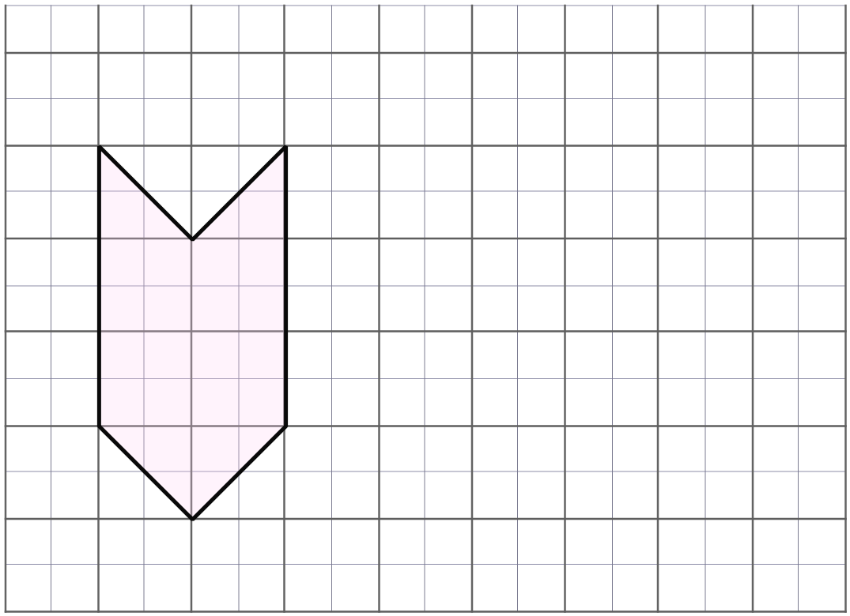

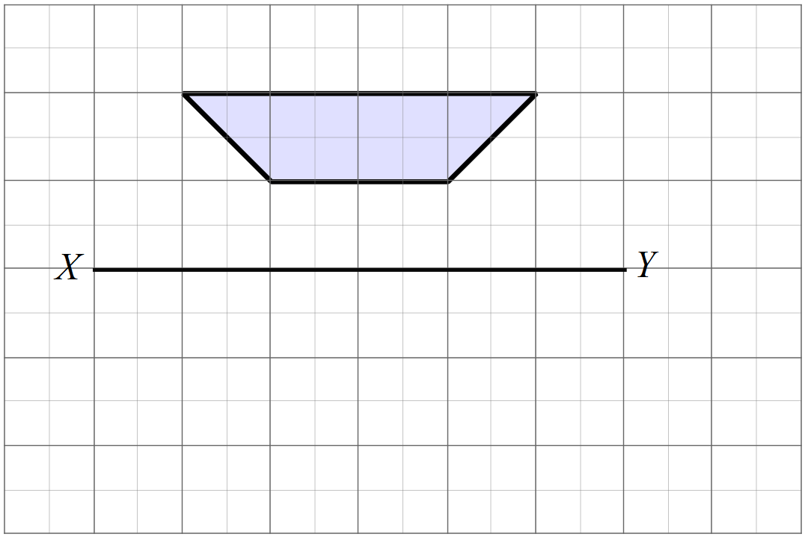Reflect the trapezium in the line XY.

Draw the trapezium in its new position.

Rotate the quadrilateral through 60° about C in an anticlockwise direction.
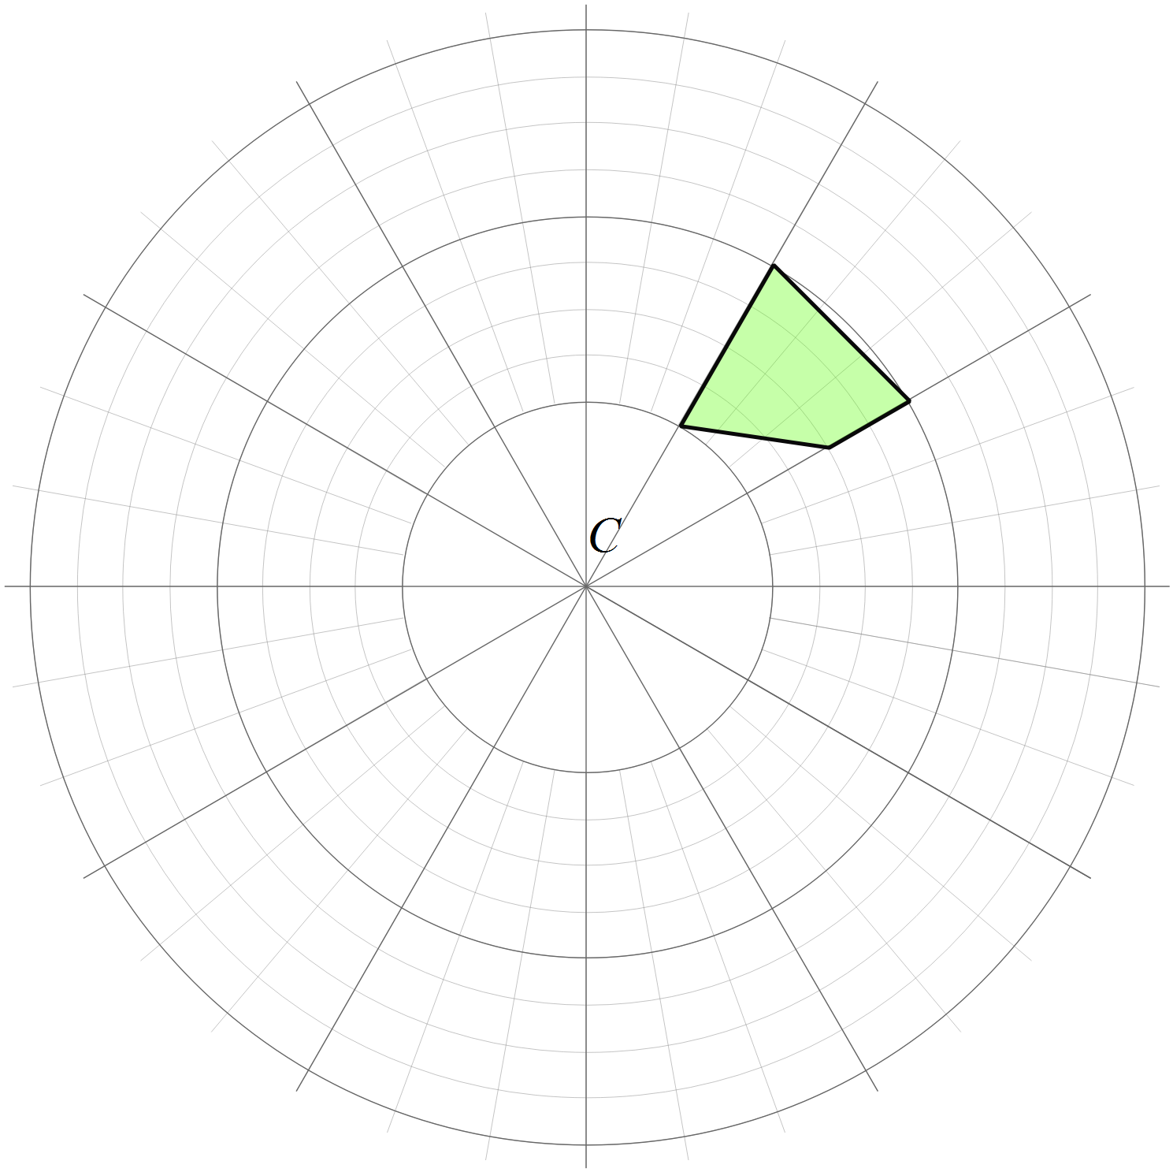

Draw the quadrilateral in its new position.

Translate the shape in the distance and direction of the arrow.
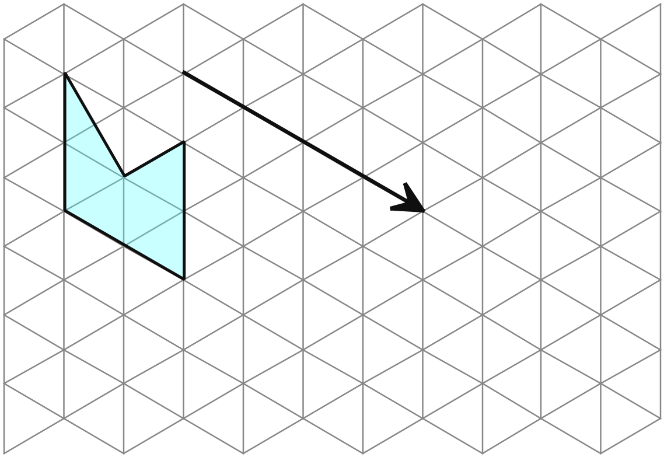

Draw the shape in its new position.

Which two trapeziums are congruent? (Write their letters in the space below.)
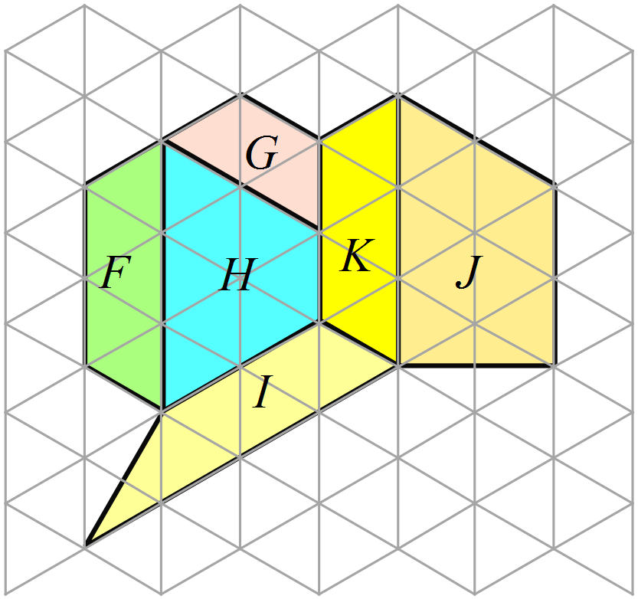

…………………………………………………
AAS is an abbreviation for one of the tests for congruent triangles. It says:

Two triangles are congruent if two angles and a side of one triangle are equal to two angles and a corresponding side of the other.

What does the test which is abbreviated as SAS say?

……………………………………………………………………………………………....

……………………………………………………………………………………………….
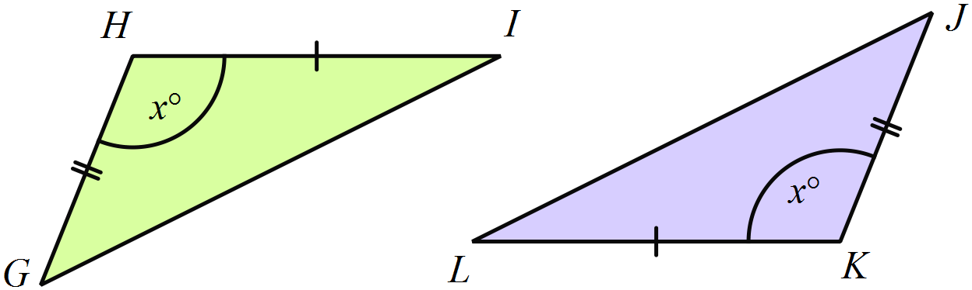Which of the congruence test (AAS, RHS, SAS or SSS) could be used to show congruence of triangles GHI and JKL?

...................................................................
A kite ABCD has a diagonal drawn.
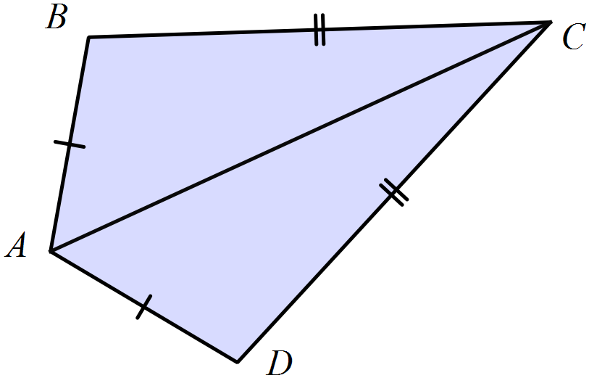Which of the congruence test (AAS, RHS, SAS or SSS) could be used to show that :

………………………………………….
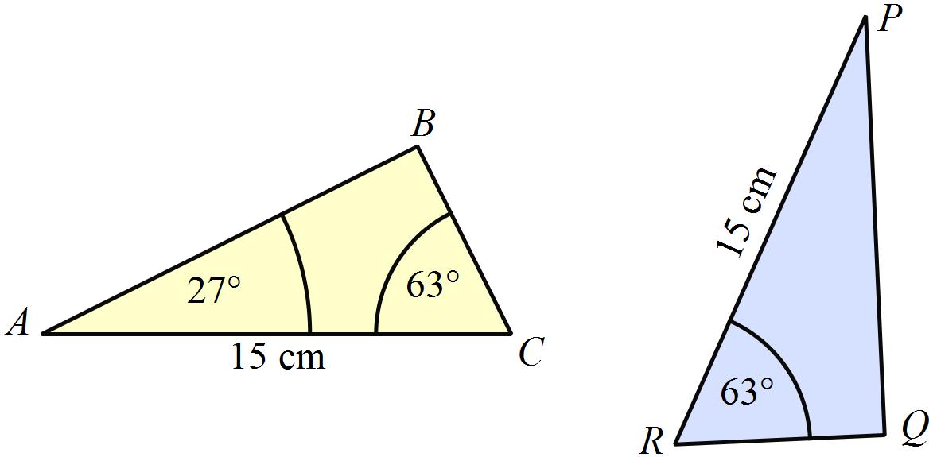What additional piece of information would need to be given about 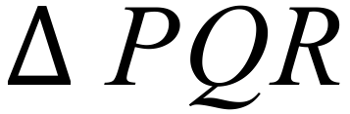 in order to prove that 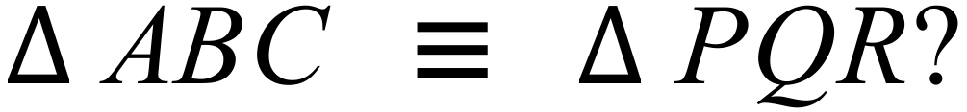

………………………………………

……………………………………….
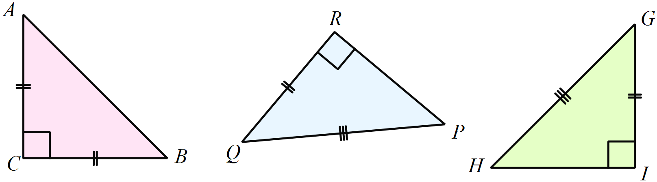Which two triangles below have enough information provided to show they are congruent to one another.

Explain your answer.

……………………………………………………………………………………………....

……………………………………………………………………………………………….
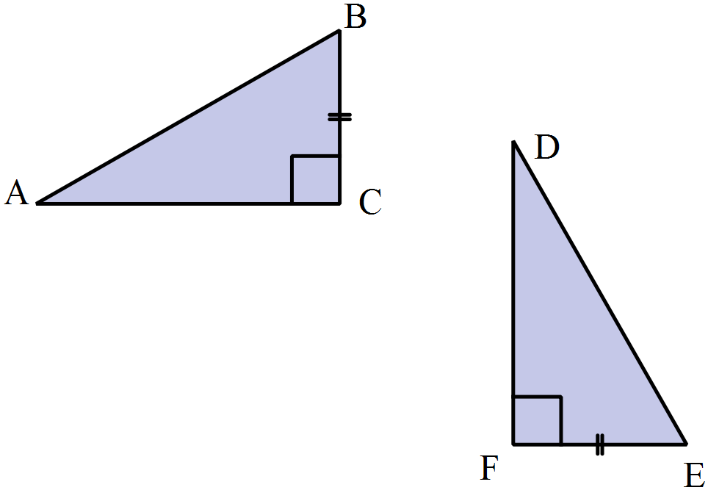In the figure below, BC = EF.
.
Give one additional piece of information would allow you to show that and which congruence test would be used?

………………………………………………

……………………………………………….
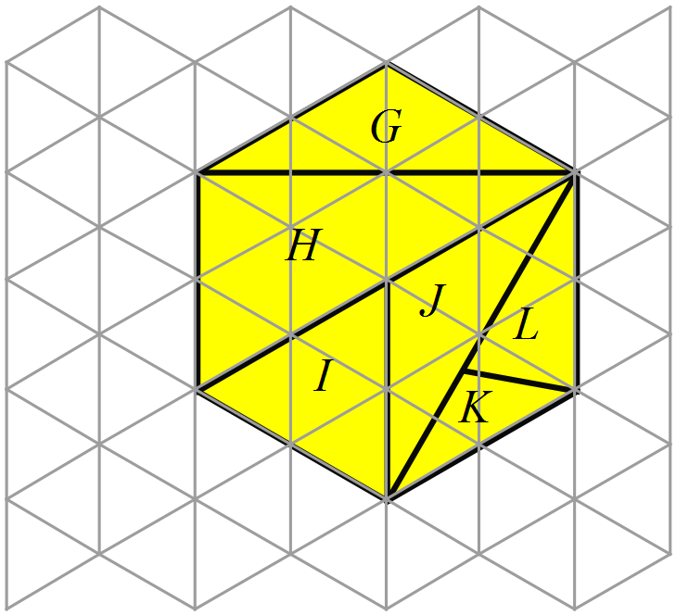The diagram at right is drawn on isometric grid paper.
It shows a regular hexagon which has been divided into a number of triangles.
Which pair of triangles are congruent and which test could be used to prove this?

………………………………………………

……………………………………………....
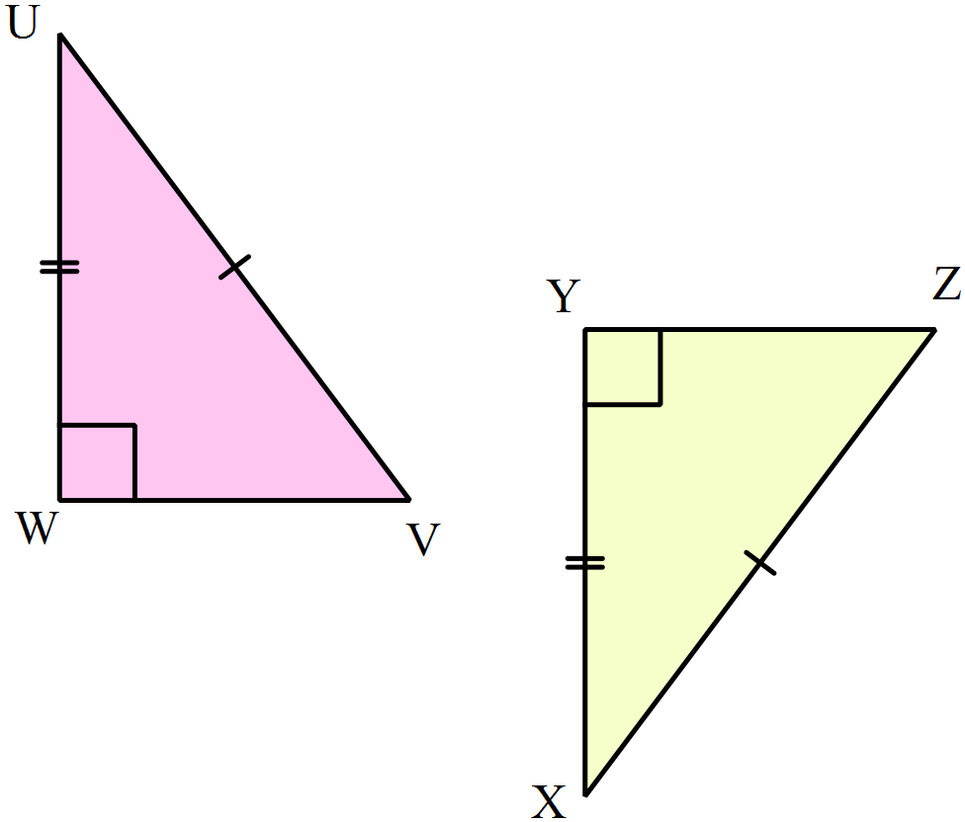UW = XY, UV = XZ and .

A proof that
has been started.

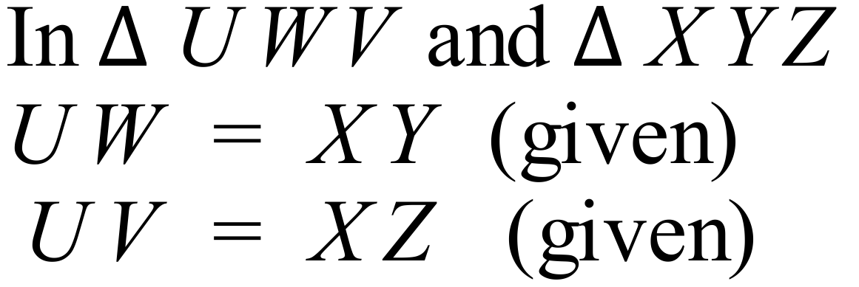

Complete the last two lines of the proof.

………………………………………………

……………………………………………....
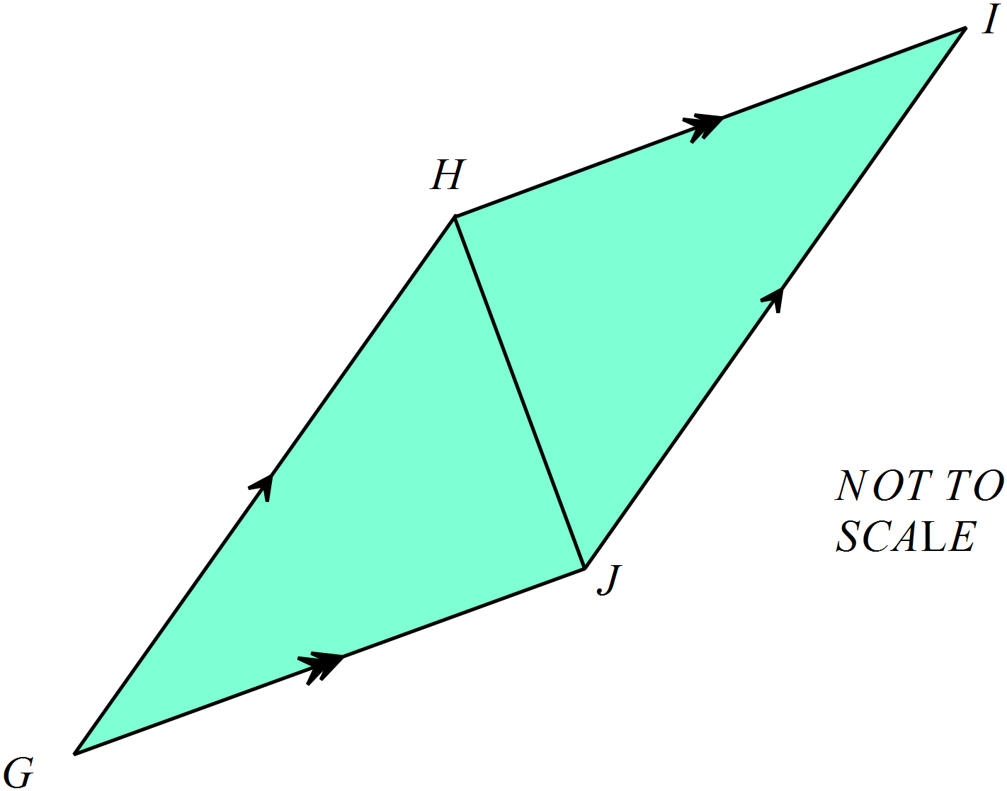Complete the proof below, by writing in the reasons for each step.

Show that 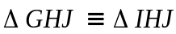
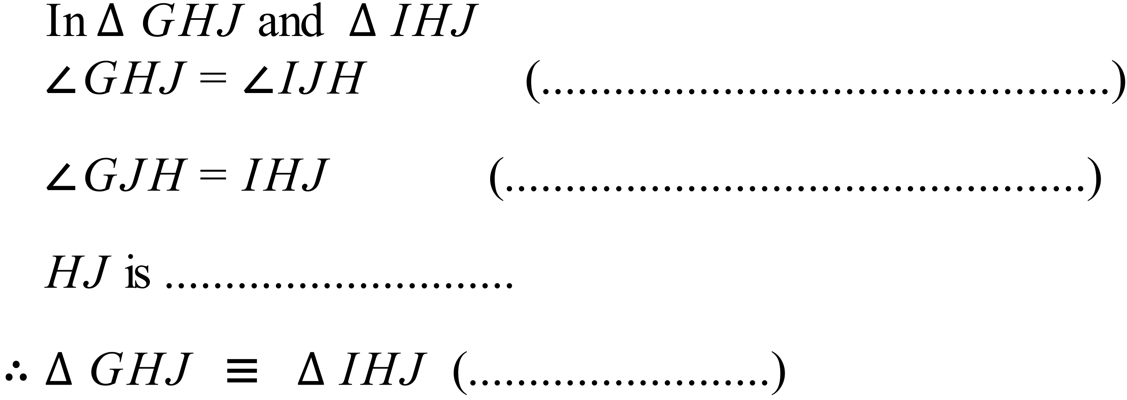

In the diagram below, DE = GE, DF is a straight line segment and 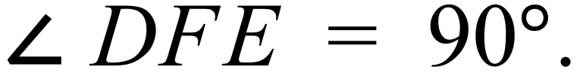
Complete the proof below, by filling in the missing information.
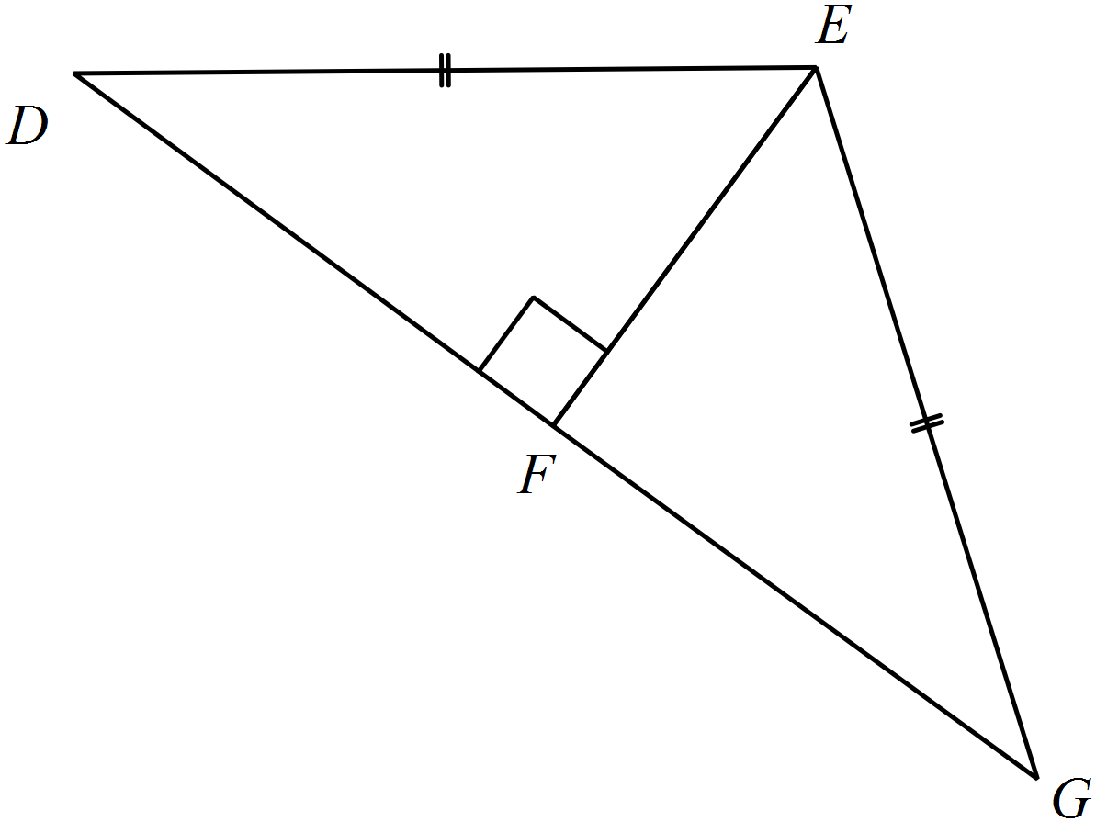
Prove that 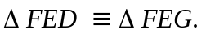

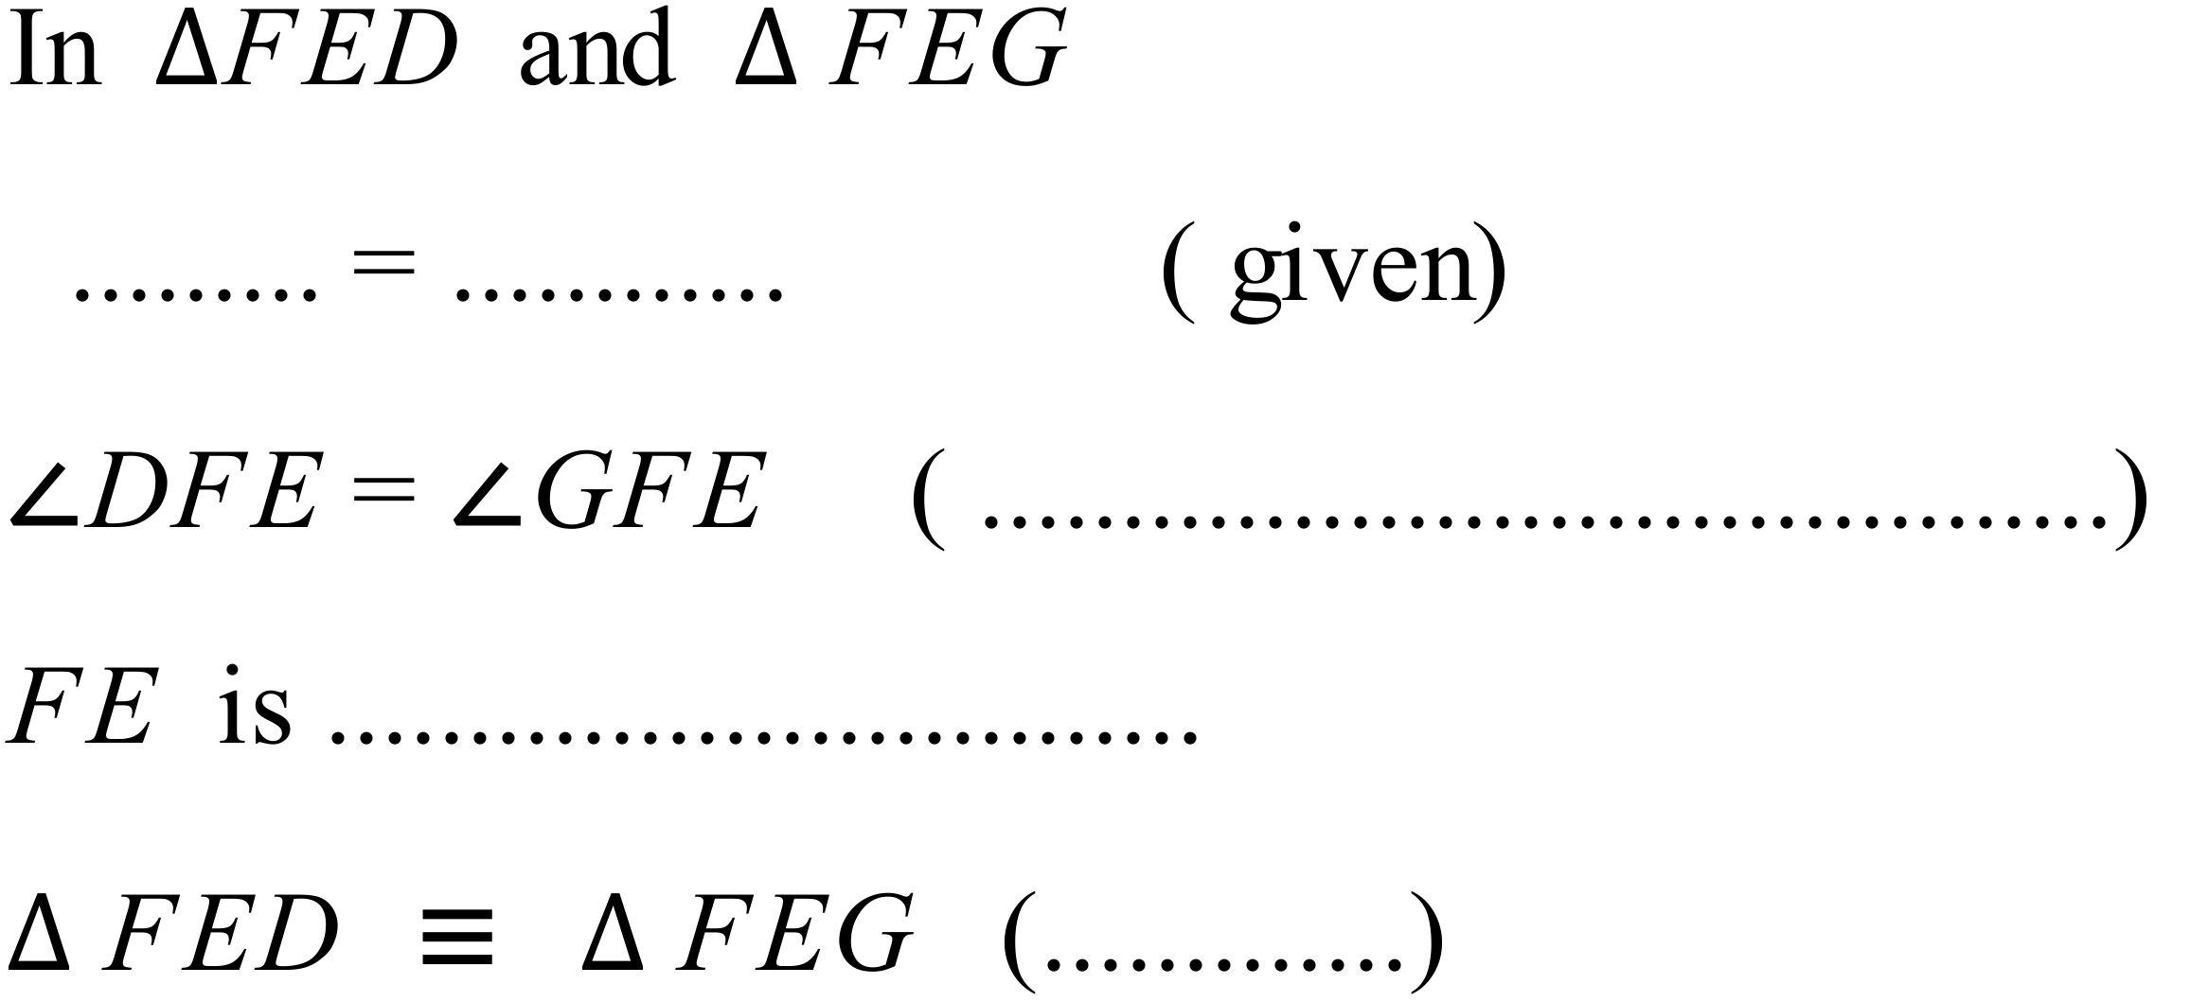

Year 10 |  | Congruence | Calculator Allowed
 |  | Congruence | Name_________________
Section 2 Multiple Choice Section
Mark all your answers on the accompanying multiple choice answer sheet, not on this test paper. You may do any working out on this test paper. Calculators are allowed for this section.
YOU WILL NEED A RULER, COMPASSES AND PROTRACTOR.
Which of the pairs of triangles listed below are congruent?
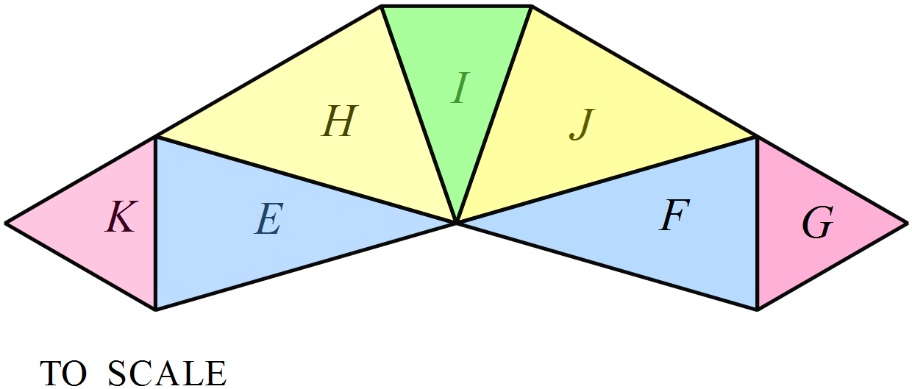

A. K and F B. K and J C. K and I D. K and G
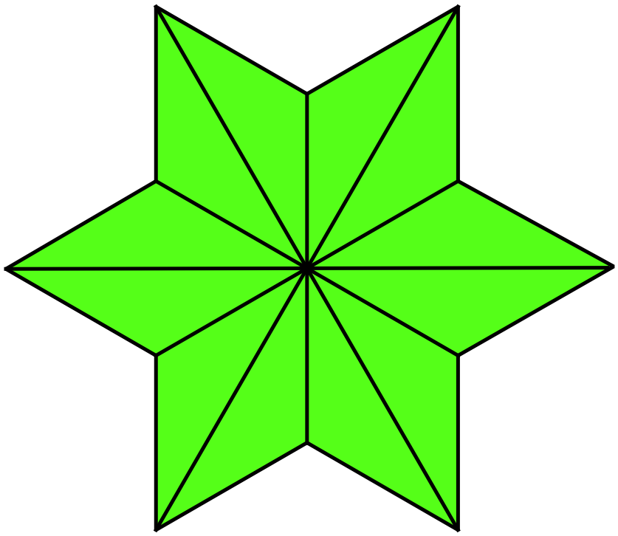How many congruent triangles are there in the shape below?

A. 4
B. 6
C. 12
D. 18

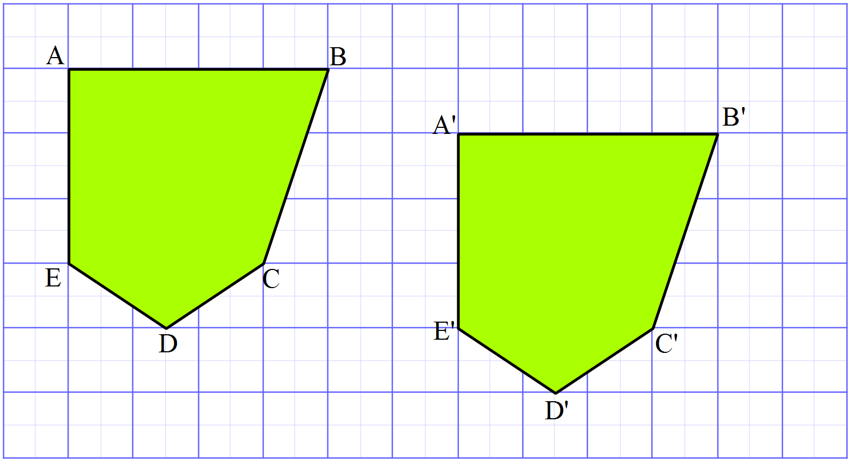What transformation could have been used to produce the congruent image 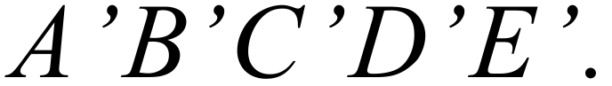

A. Reflection.
B. Rotation through 90º.
C. Rotation through 180º.
D. Translation.

The triangle OPQ is reflected in the interval OQ.
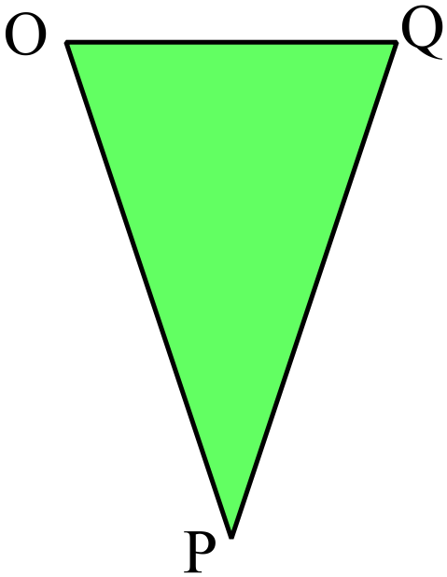
Which triangle could be the image?

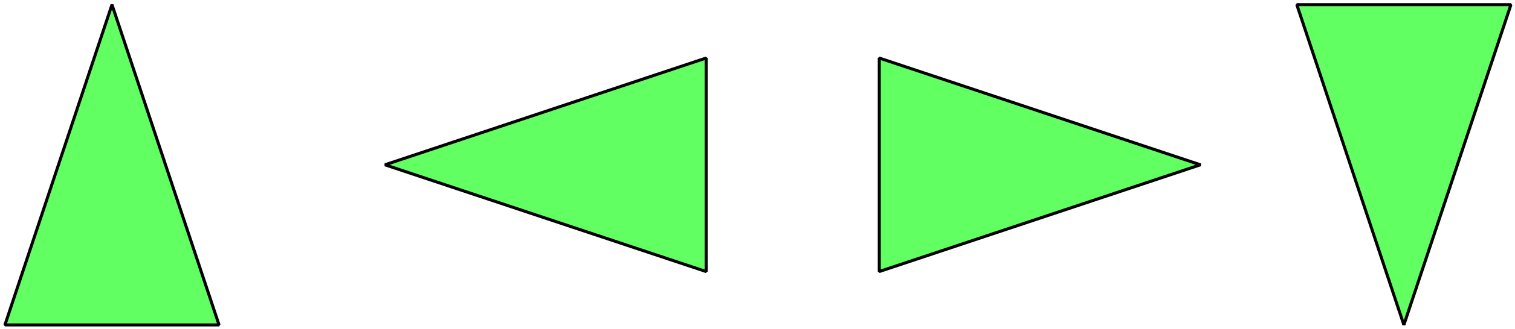
- B. C. D.

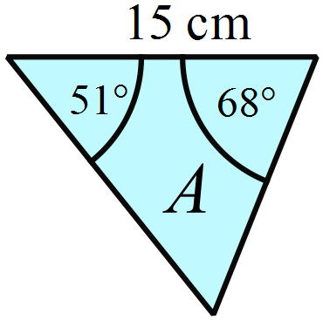Triangle A has the measurements shown at right.

Which of the triangles below is congruent to Triangle A?

The diagrams are not to scale.

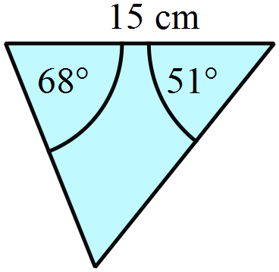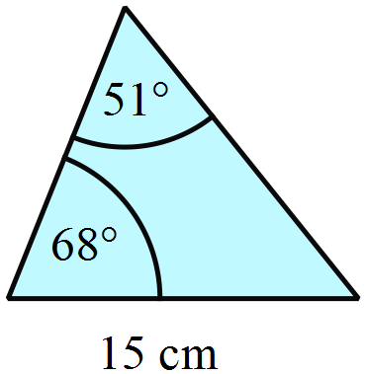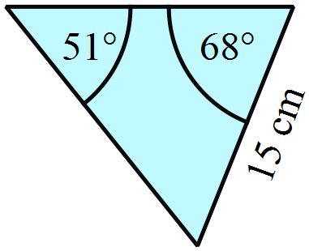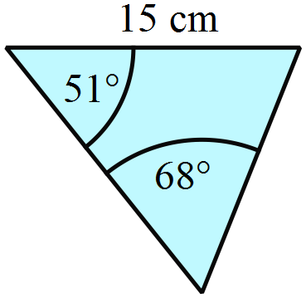 A. B. C. D.

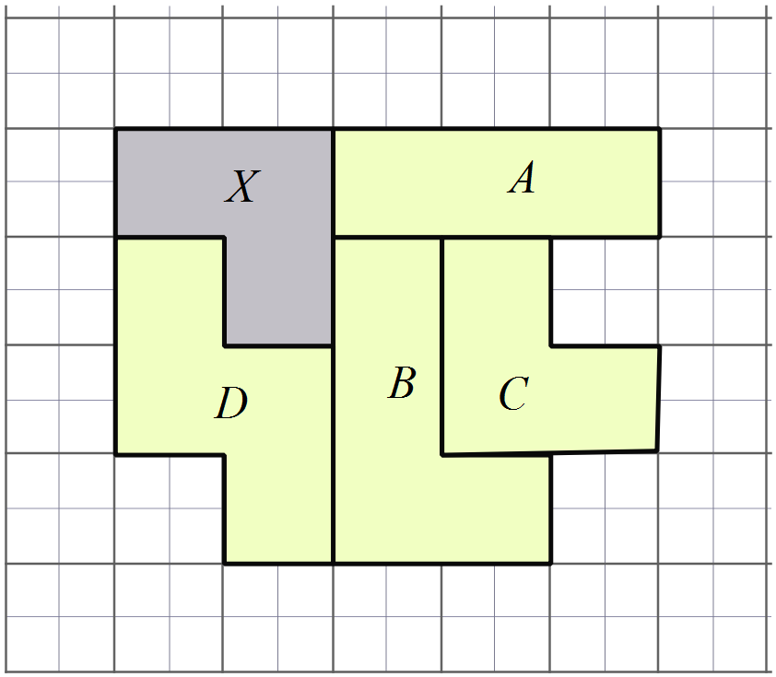Which shape is congruent to shape X?

A. Shape A
B. Shape B
C. Shape C
D. Shape D

Which triangles are congruent?
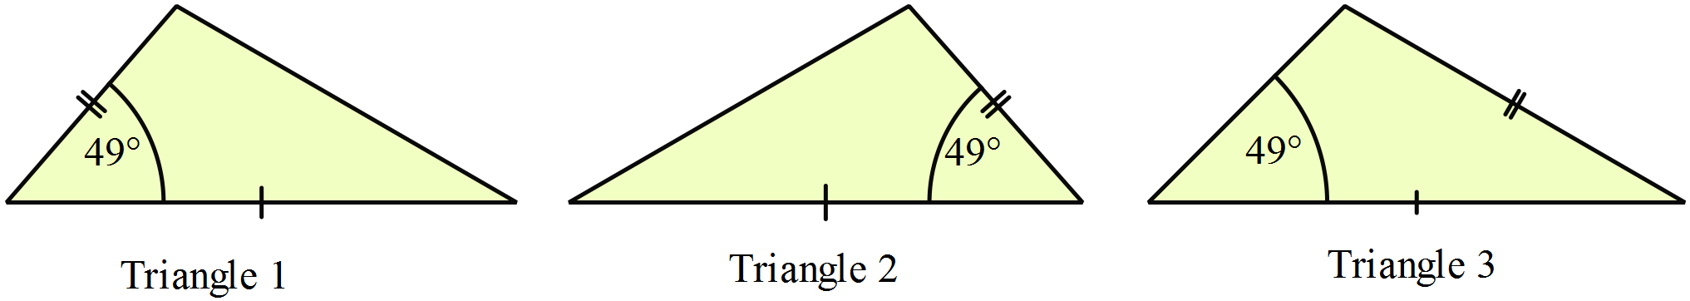

A. All three triangles.
B. Triangles 1 and 2.
C. Triangles 1 and 3.
D. Triangles 2 and 3.
Figure ABCD is moved to an image 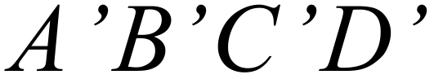 by a single transformation.
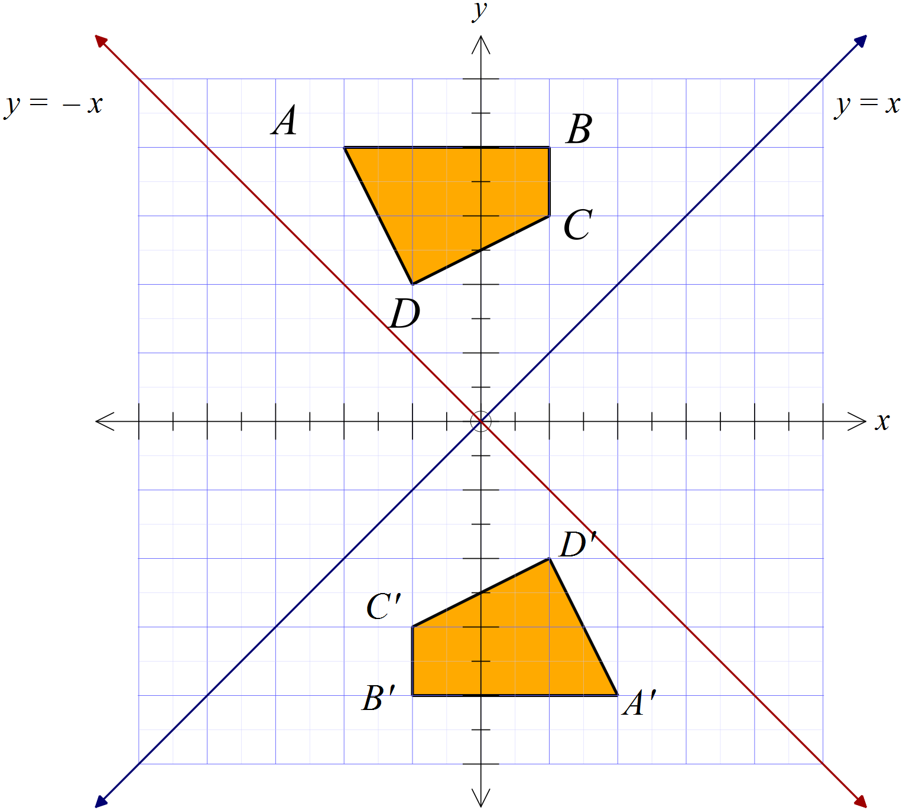What was the transformation?

A. A clockwise rotation of 180º about the origin.
B. A clockwise rotation of 90º about the origin.
C. A reflection in the line y = x.
D. A reflection in the line y = -x

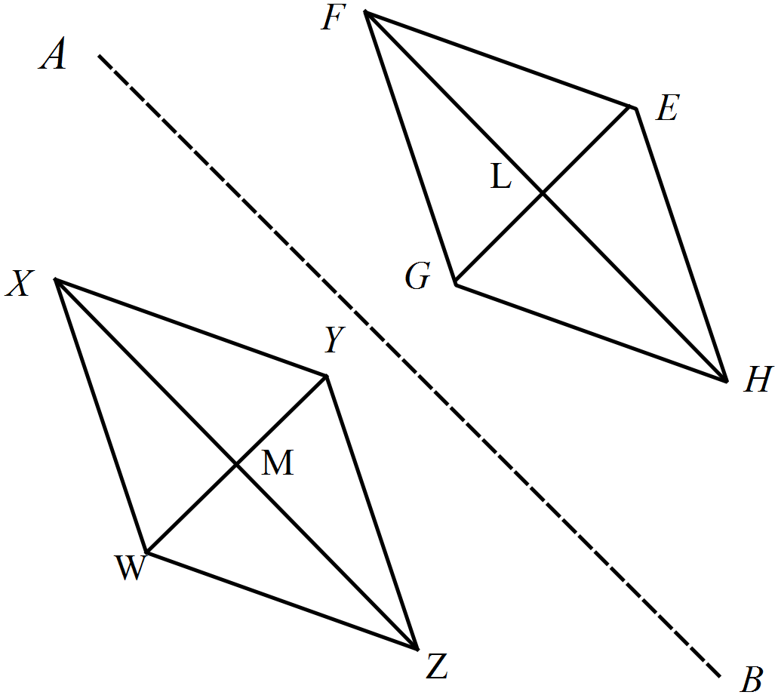The rhombus WXYZ is reflected in the line segment AB, to give the rhombus EFGH.

Which is not a pair of congruent triangles?

A.
B. 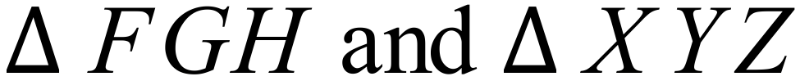
C.
D.
Which of the congruence tests is sufficient to prove that ?
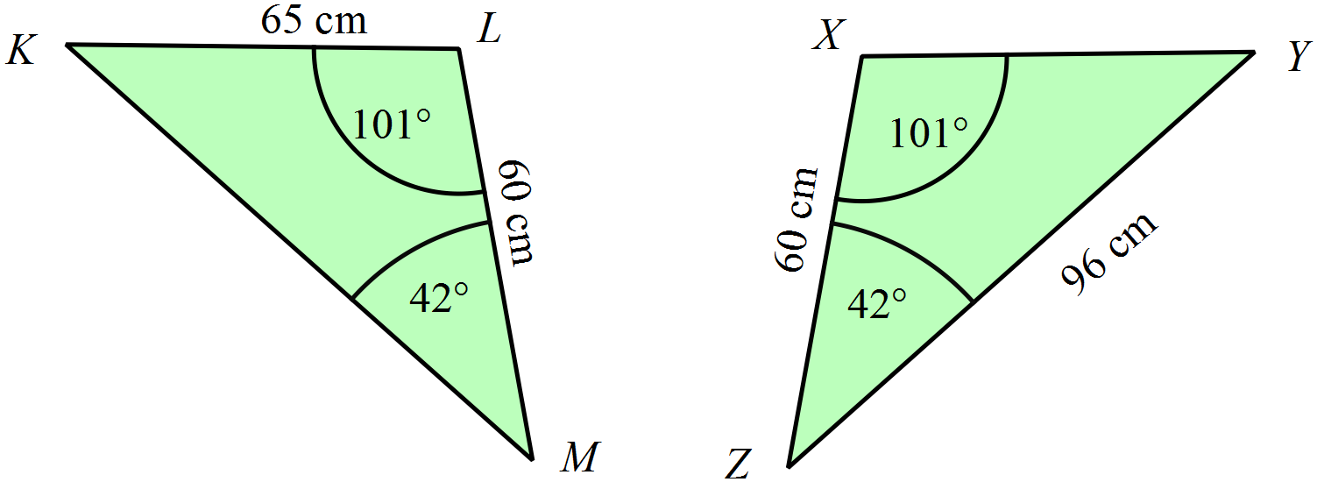

A. AAS B. RHS C. SAS D. SSS
Which triangle is congruent to 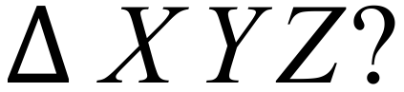 ?
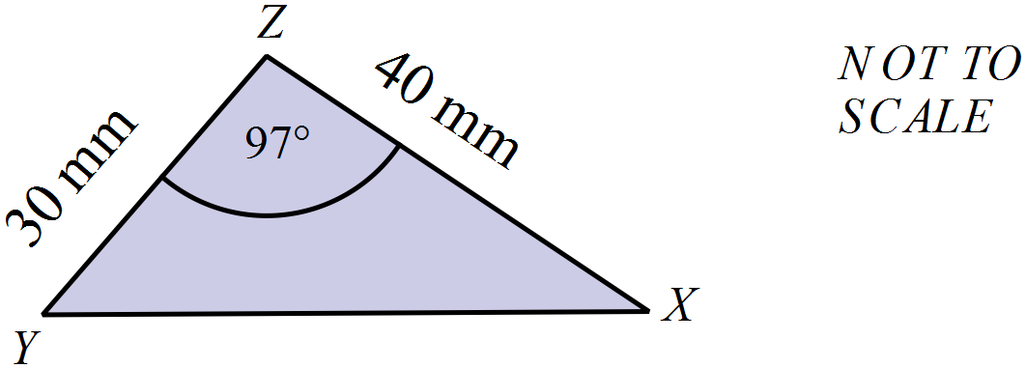

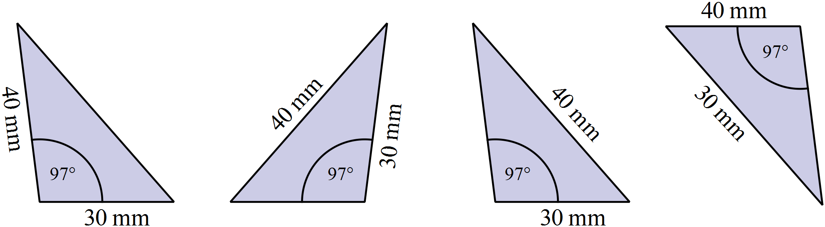 A. B. C. D.

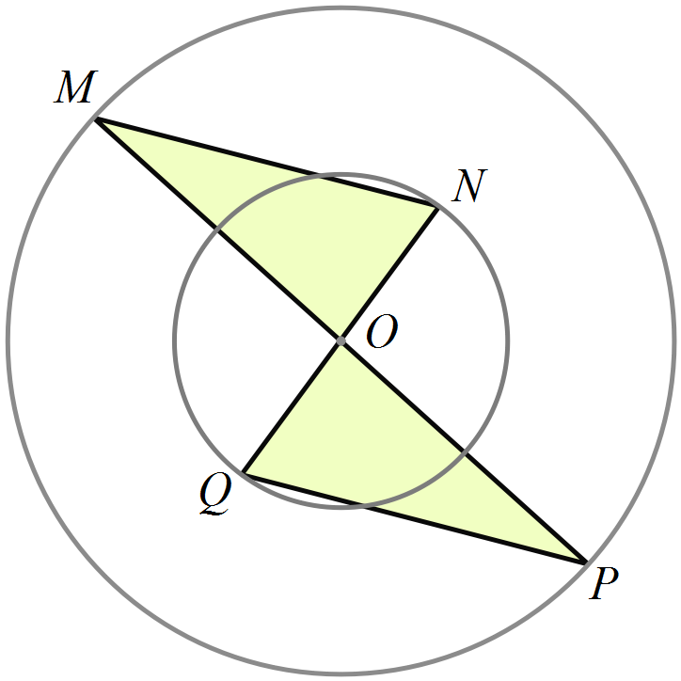The circles shown are concentric with centre O.

MP and NQ are diameters of the larger and smaller circles respectively.

Which of the congruence tests is sufficient to prove that 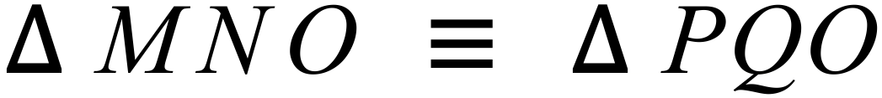 ?

A. AAS B. RHS
C. SAS D. SSS

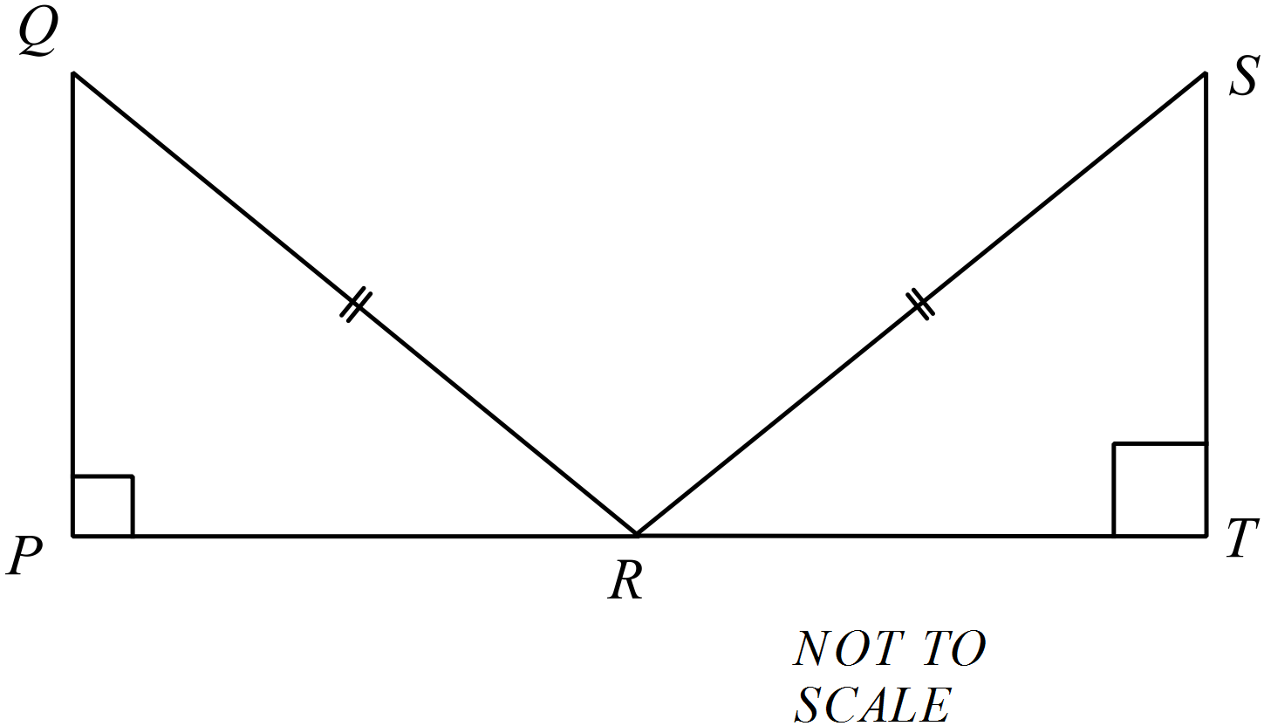
QR = SR and R bisects PT.
Which of the congruence tests could be used to show that
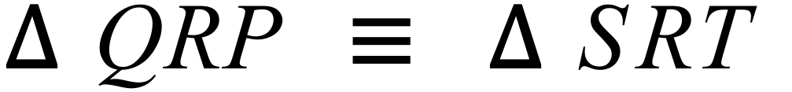 ?

A. AAS
B. RHS
C. SAS
D. SSS
In the figure below, BC = EF.
.
Which single additional piece of information would allow you to show that

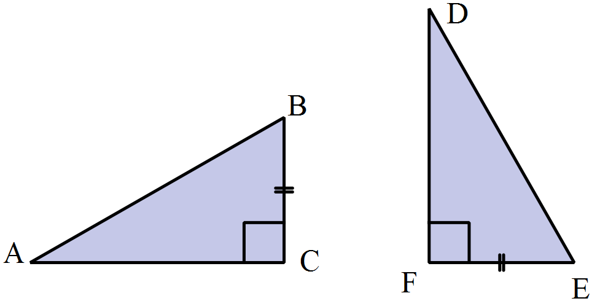

A. 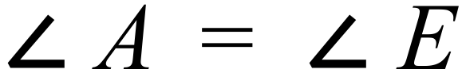 B.  C. BA = ED D. CA = FD
In 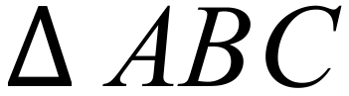, D bisects AC.
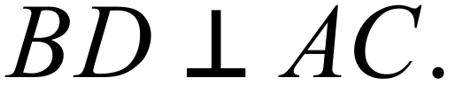
In the proof that 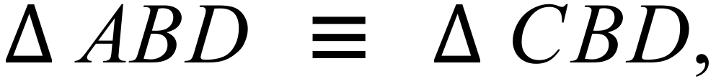 a reason has been left out indicated by *******
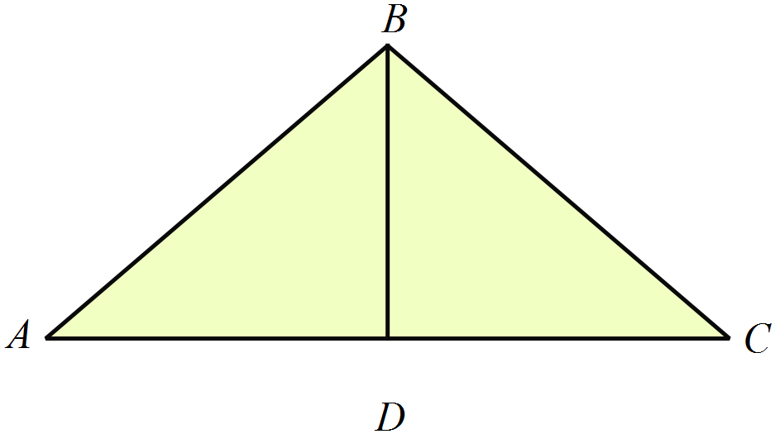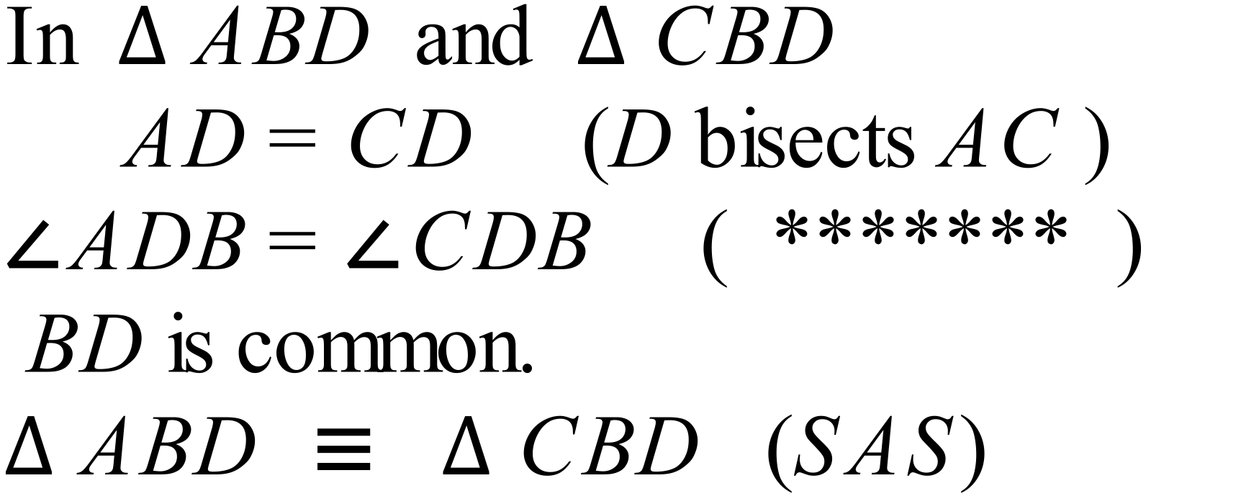
Which reason should go in the spot?

A. Alternate angles on parallel lines.

B. Base angles of isosceles triangle.

C. Right angles on a straight line.

D. Vertically opposite angles.

Year 10 | Congruence | Calculator Allowed
Year 10 | Congruence | Name___________________
Section 3 Longer Answer Section
Write all working and answers in the spaces provided on this test paper.
YOU WILL NEED A RULER, COMPASSES AND PROTRACTOR.

 |  | Marks
1. | (a) Reflect the polygon JKLMN in the line OP.  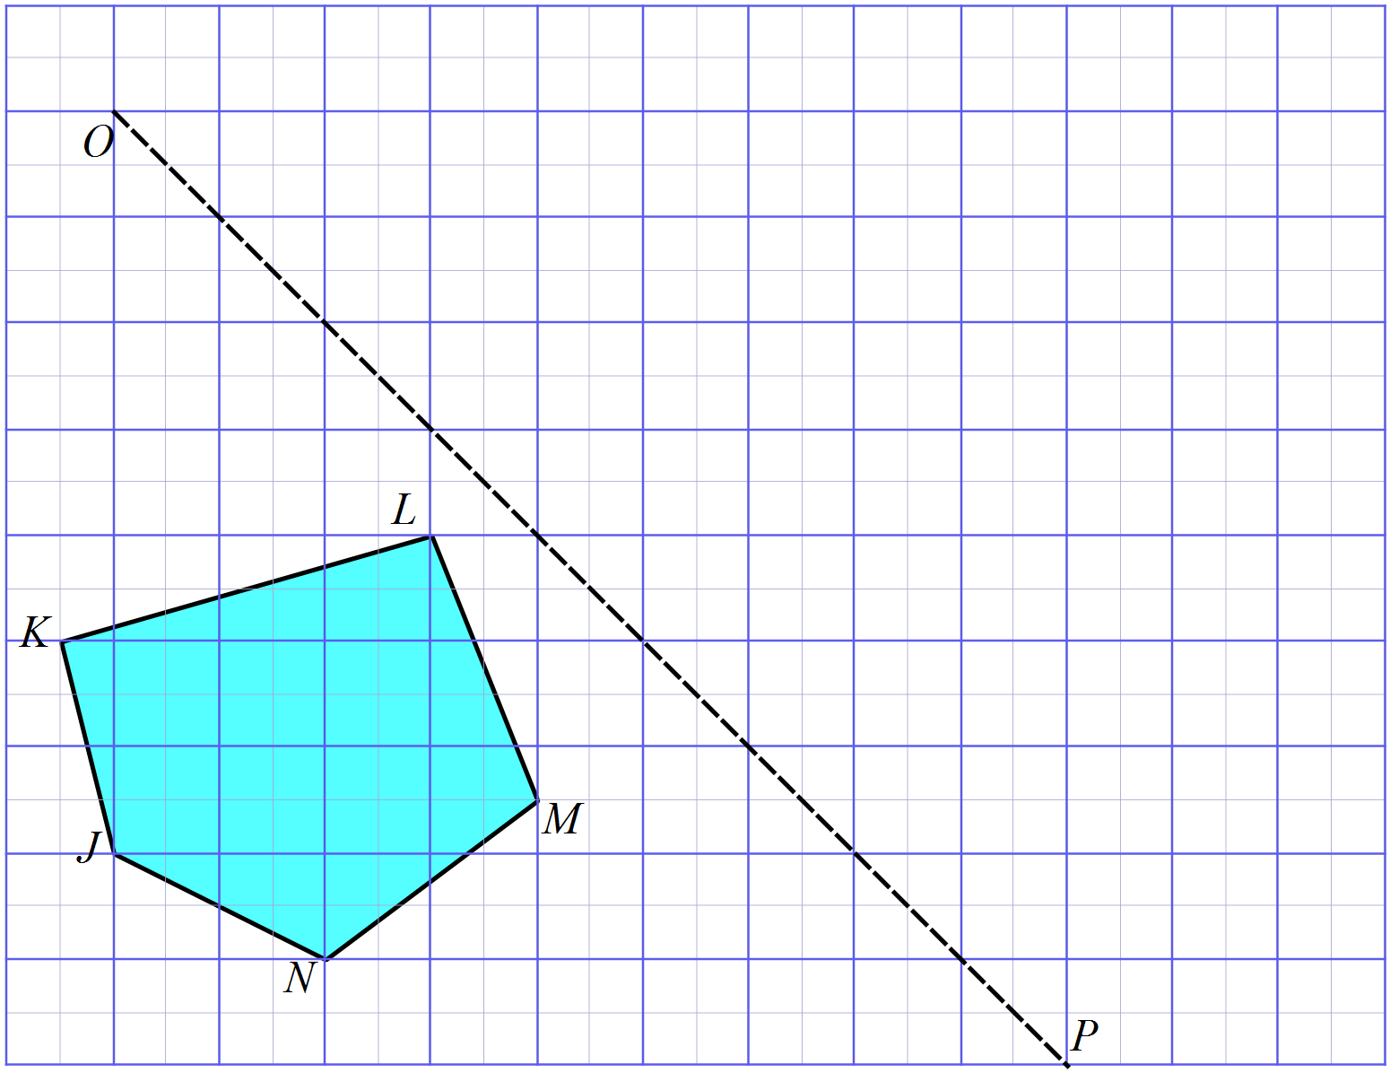 | 2
 | (b) Label the image after reflections as J’K’L’M’N’. | 1
 | (c) What could you say about ?  ……………………………………………………………………………………..  …………………………………………………………………………………….. | 1
2. | Draw the image of the shape below when it is rotated through 180º about the point C.  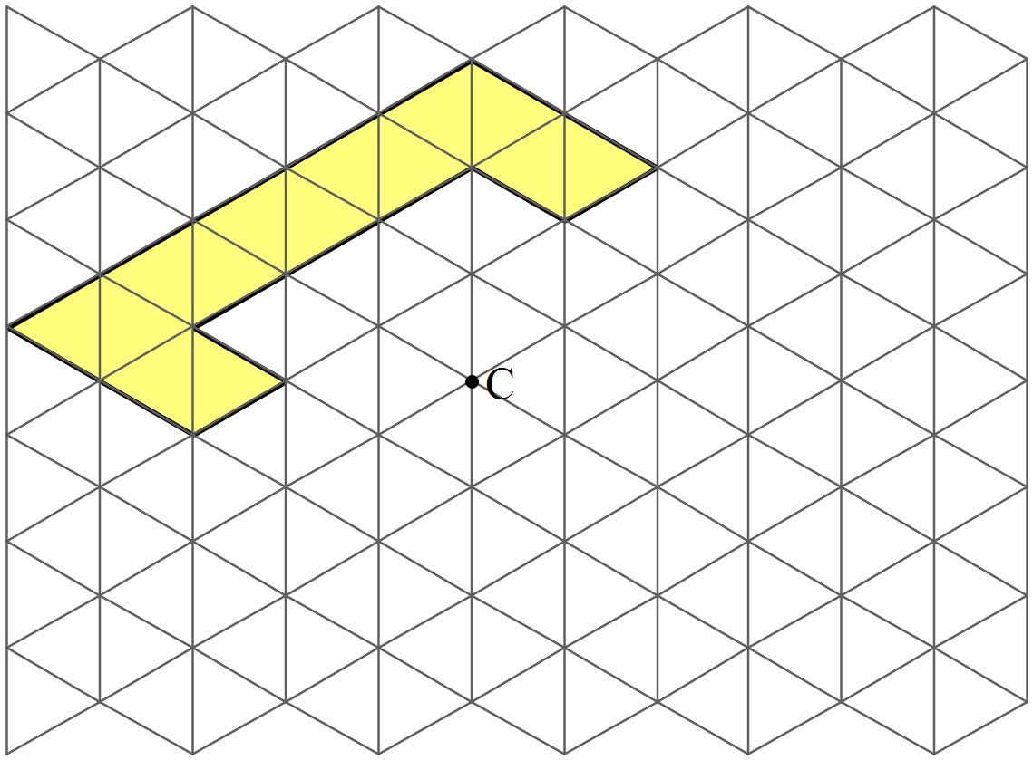 | 2
3. | (a) A triangle has two sides whose lengths are given below and has an angle of 40º between these two sides. Use instruments to accurately draw the triangle. | 2
 | (b) A triangle has a base which measures 8 cm, with an angles of 30º and 50º at the ends of the base. Use instruments to accurately draw the triangle. | 2
4. | (a) Prove that  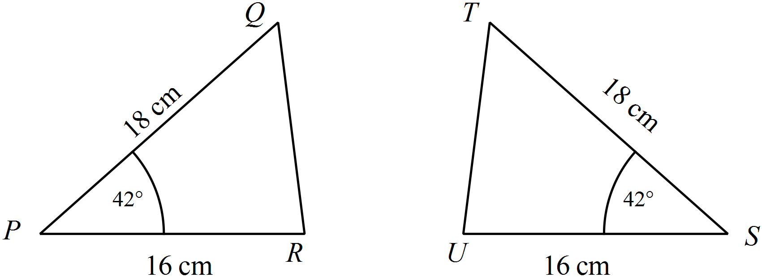  ………………………………………………………………………………………………………………………………………………….  …………………………………………………………………………………………………………………………………………………  …………………………………………………………………………………………………………………………………………………  ………………………………………………………………………………………………………………………………………………….  …………………………………………………………………………………………………………………………………………………  ………………………………………………………………………………………………………………………………………………… | 2
 | (b) Prove that  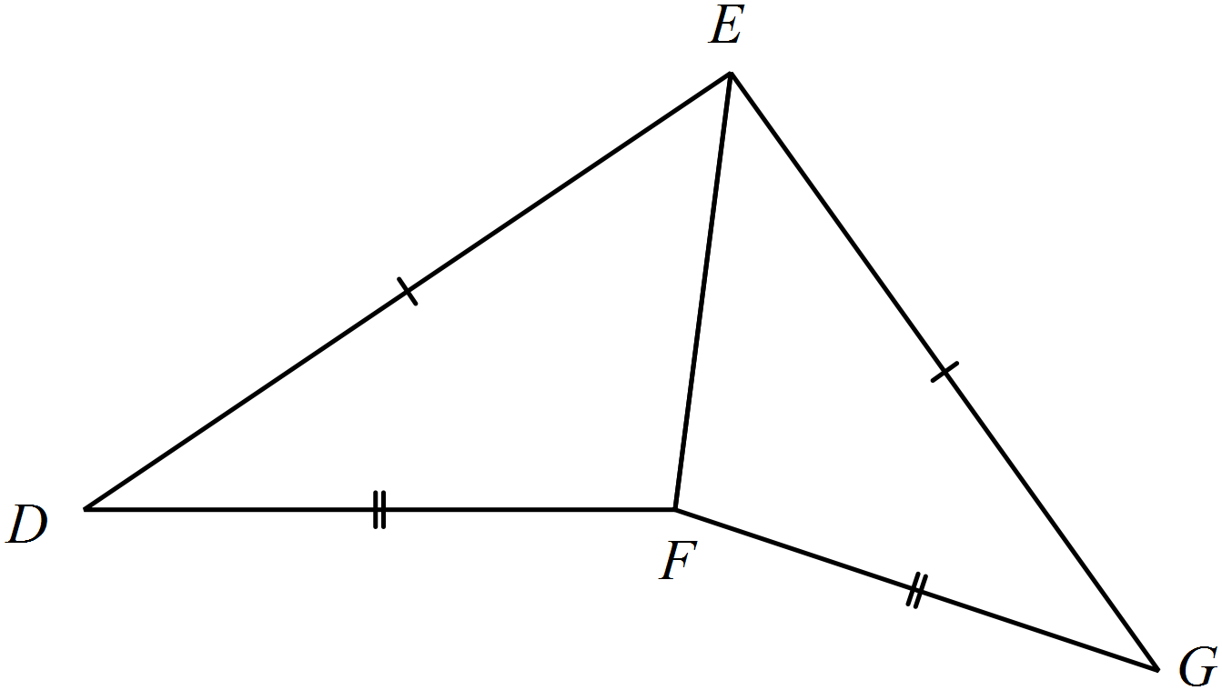  …………………………………………………………………………………………………………………………………………………  …………………………………………………………………………………………………………………………………………………  ………………………………………………………………………………………………………………………………………………….  …………………………………………………………………………………………………………………………………………………  ………………………………………………………………………………………………………………………………………………… | 2
 | (c) In the quadrilateral GHIJ, the diagonals are equal in length and GJ = HI.  Prove that  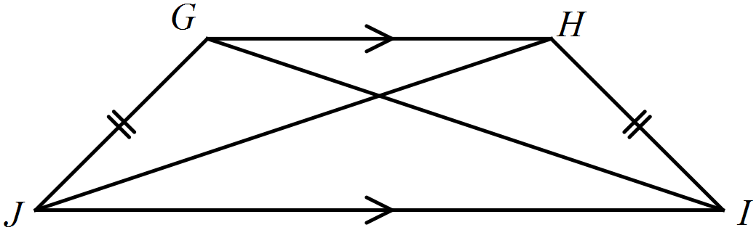  ………………………………………………………………………………………………………………………………………………….  …………………………………………………………………………………………………………………………………………………  …………………………………………………………………………………………………………………………………………………  ………………………………………………………………………………………………………………………………………………….  ………………………………………………………………………………………………………………………………………………… | 2

Multiple Choice Answer Sheet
Congruence
Name _____________________________________________
Completely fill the response oval representing the most correct answer.

1. A B C D
2. A B C D
3. A B C D
4. A B C D
5. A B C D
6. A B C D
7. A B C D
8. A B C D
9. A B C D
10. A B C D
11. A B C D
12. A B C D
13. A B C D
14. A B C D
15. A B C D
Year 10 |  | Congruence | Non Calculator
Section 1 Short Answer Section
ANSWERS
No. | WORKING |  | ANSWER
 | 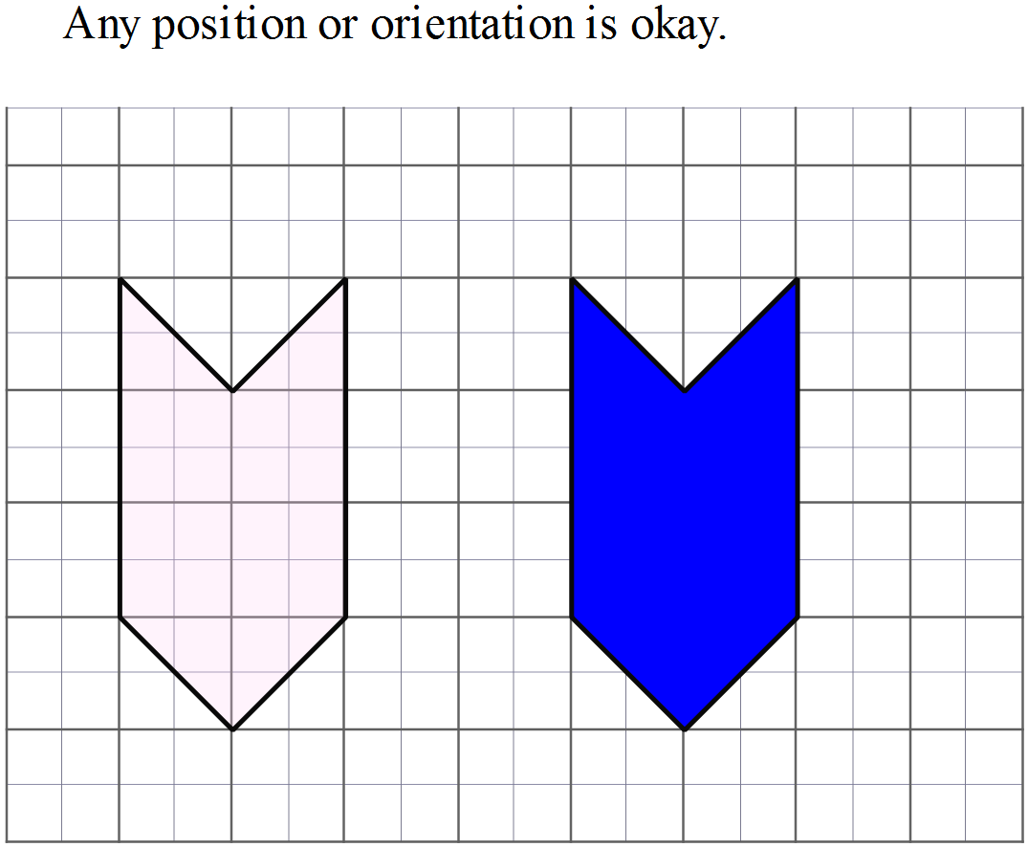 |  | Solution is the darker shaded shape on the diagram; can be in any position.
 | 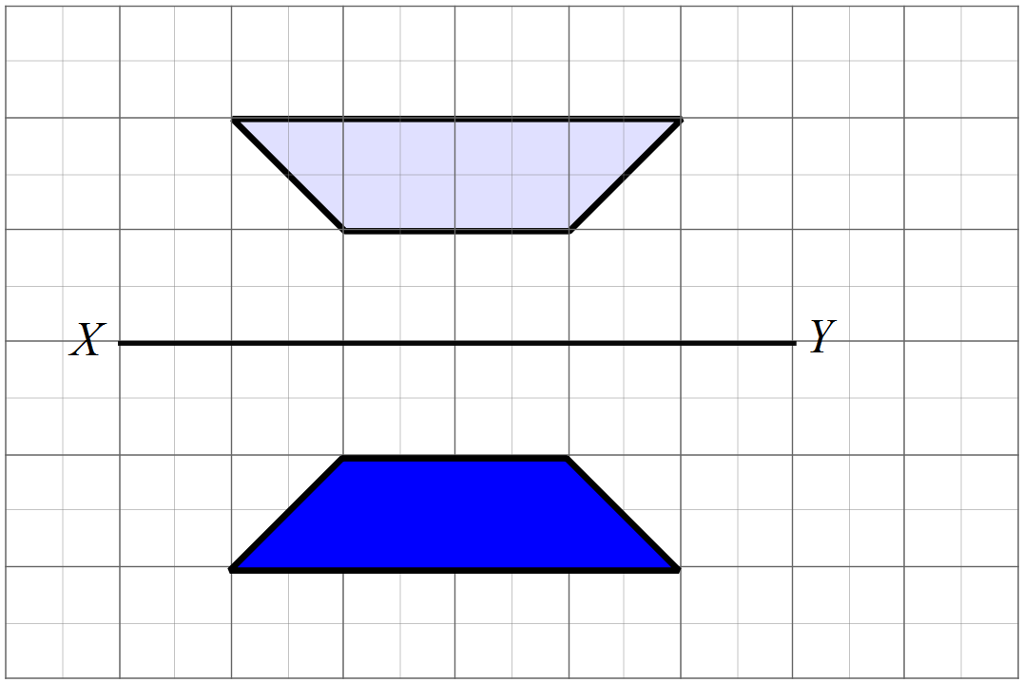 |  | Solution is the darker shaded shape on the diagram; must be in the position shown.
 | 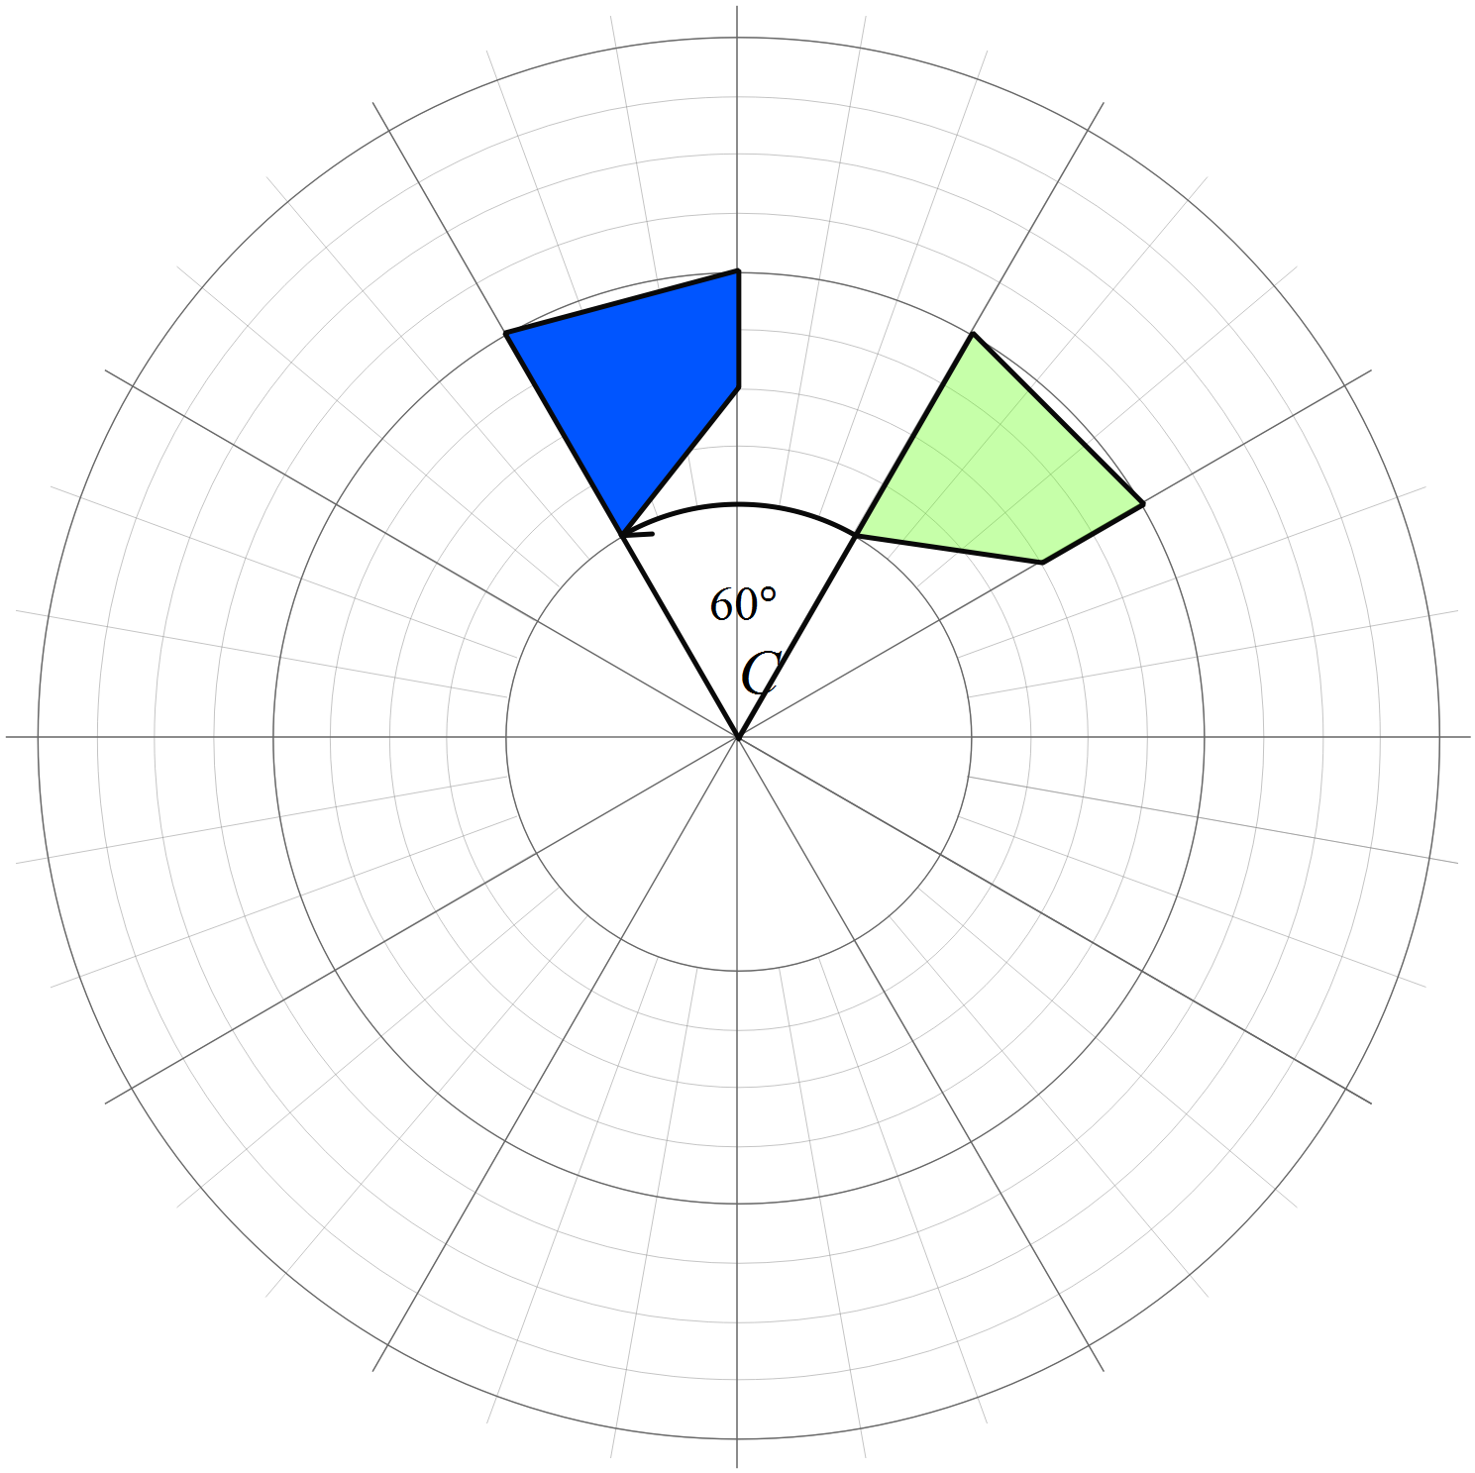 |  | Solution is the darker shaded shape on the diagram; must be in the position shown.
 | 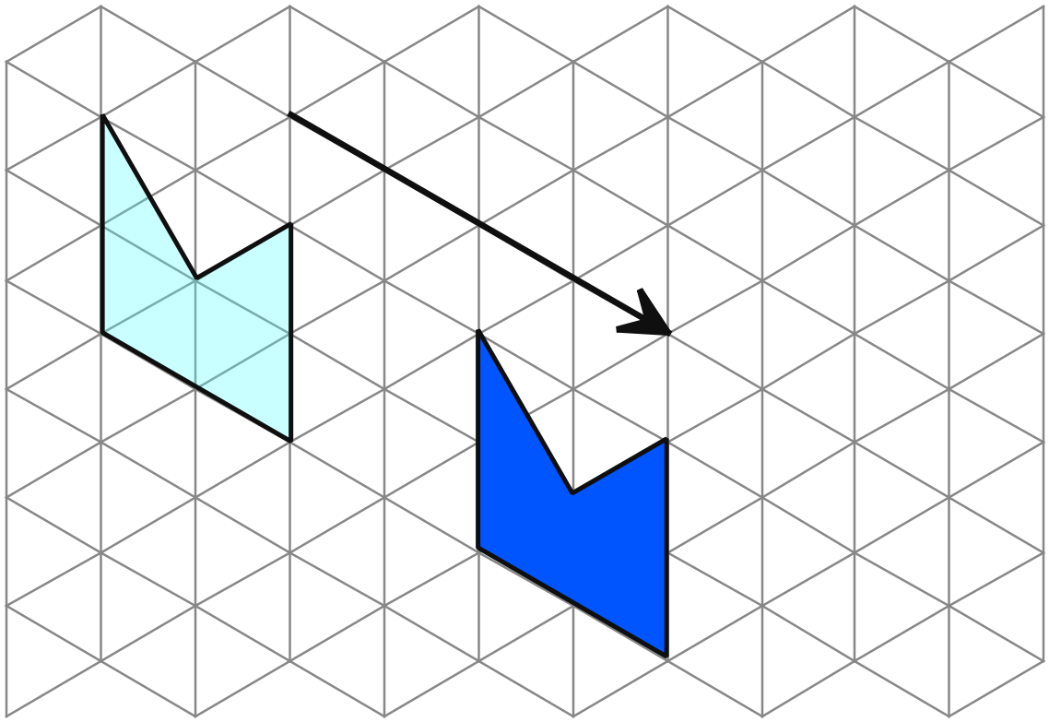 |  | Solution is the darker shaded shape on the diagram; must be in the position shown.
 | 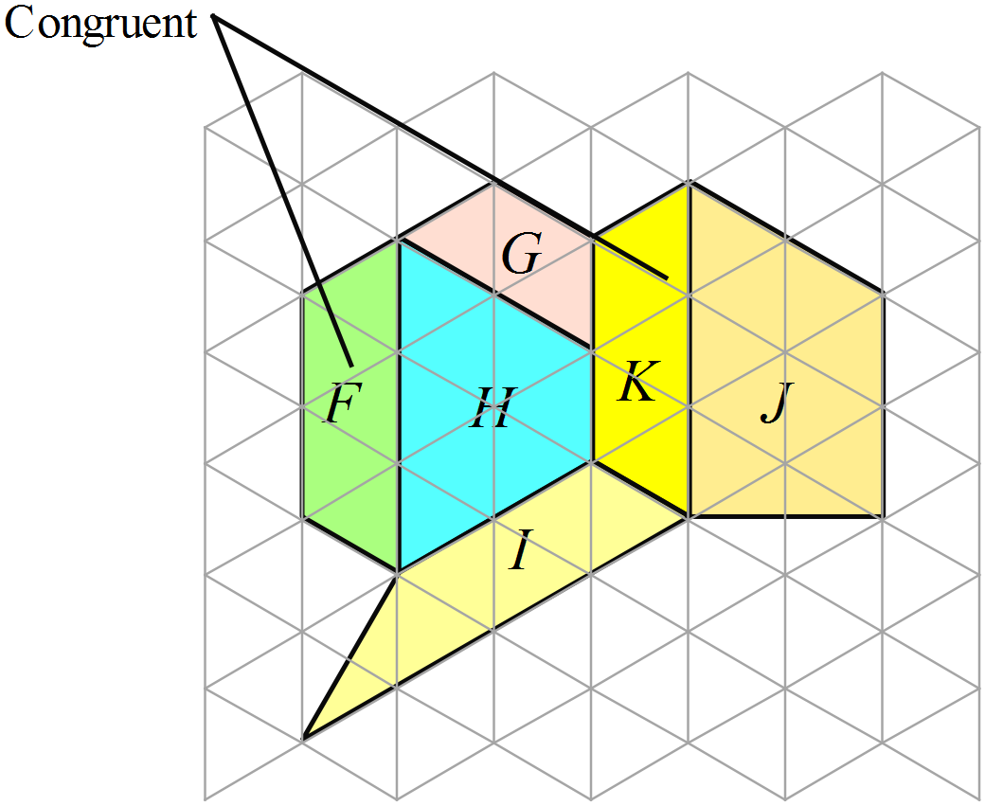 |  | F and K
 | SAS says that two triangles are congruent if two sides and an included angle of one triangle are equal to two sides and an included angle of the other. |  | Statement shown
 | There are two sides and an included angle equal. (SAS) |  | SAS
 | As AC is common and 2 sides are given, SSS could be used. |  | SSS
 | To use AAS, you would need that 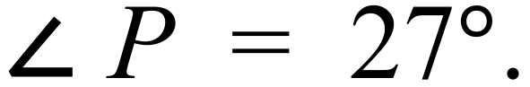
 |  |  | See explanation
 | AC = FD would allow use of SAS.  AB = DE would allow use of RHS.  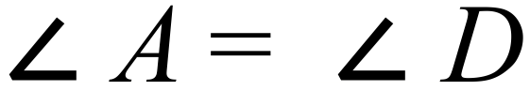 would allow use of AAS.   would allow use of AAS. |  | Any one of the 4 choices given at left is correct.
 | Triangles G and J are congruent and since there is grid behind, we can use SSS, AAS or SAS to prove congruence. |  | Triangles G and J are congruent using SSS, AAS or SAS.
 |  |  | provide the two lines
 | 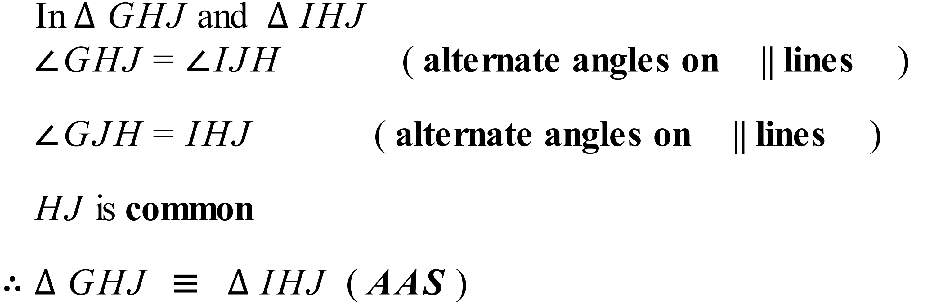 |  | Bold reasons are needed.
 | 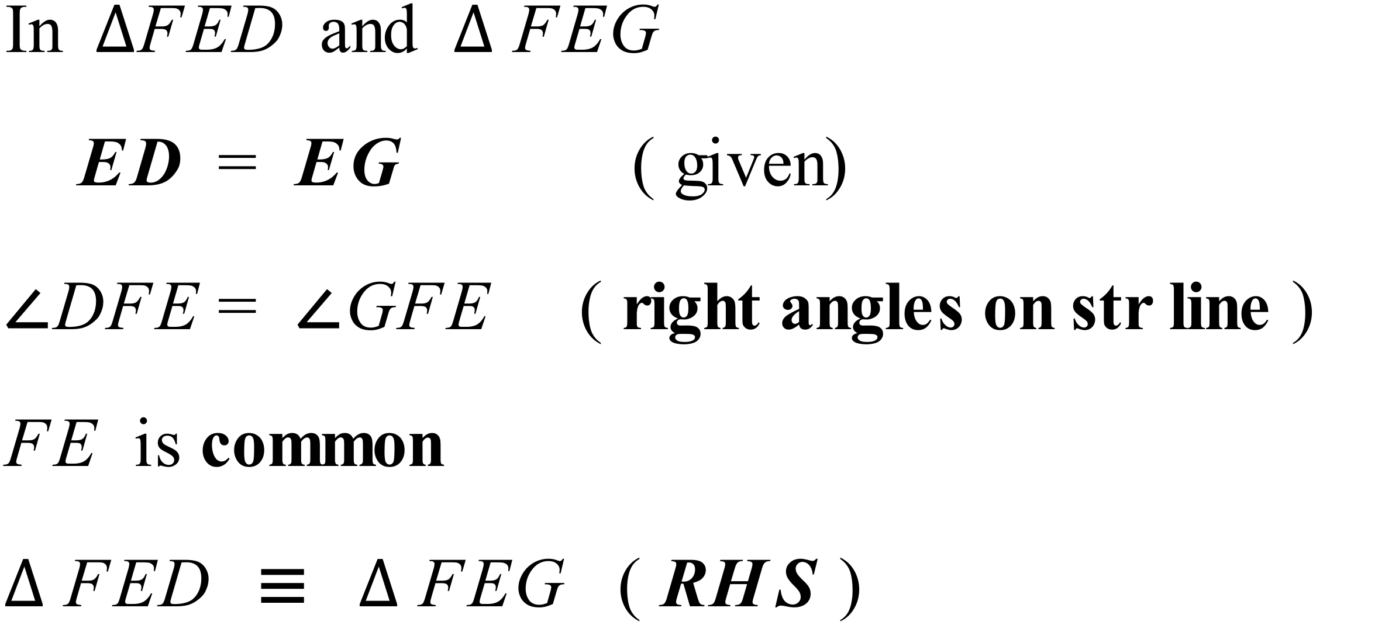 |  | Bold lines are needed

Year 10 |  | Congruence | Calculator Allowed
Section 2 Multiple Choice Section
ANSWERS
No. | WORKING |  |  | ANSWER
 | The only triangle congruent to K is G. |  |  | D
 | There are 12 |  |  | C
 | Translation |  |  | D
 | A is a reflection in the line OQ |  |  | A
 | B is congruent through AAS. |  |  | B
 | C is congruent to X |  |  | C
 | Triangles 1 and 2 are congruent SAS. |  |  | B
 | A clockwise rotation of 180º about the origin. |  |  | A
 | 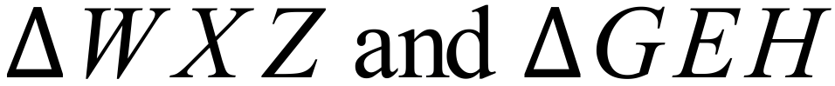 are not congruent  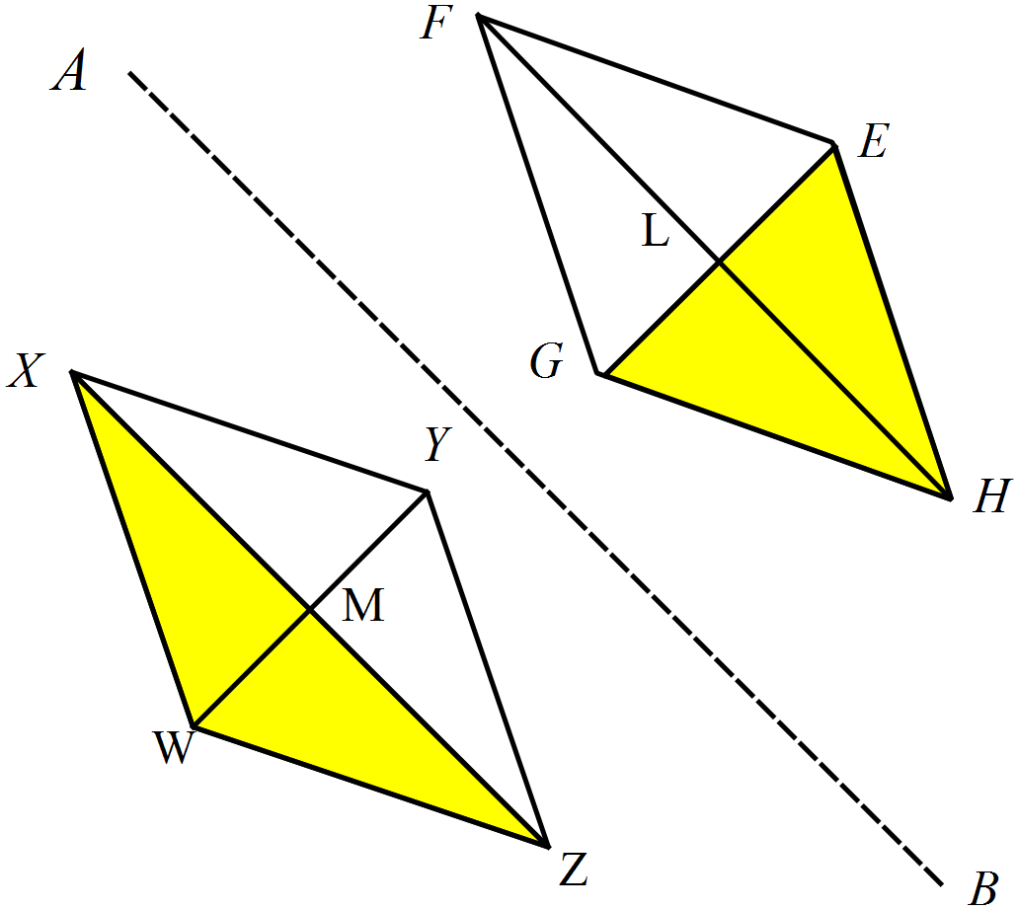 |  |  | D
 | AAS using the 60 cm side and the angles 101º and 42º. |  |  | A
 | A is congruent to the given triangle using SAS. |  |  | A
 | Using the equal radii of the larger and smaller circels and the vertically opposite angles we can show congruence using SAS. |  |  | C
 | Can use RHS with angles P and T as the right angles,  PR = RT as equal sides, and QR = SR as equal hypotenuses. |  |  | B
 | together with the right angles and equal sides allows AAS. |  |  | B
 | , because right angles on a straight line are equal. |  |  | C

Multiple Choice Answer Sheet
Congruence
Name _______ANSWERS_______________________________
Completely fill the response oval representing the most correct answer.

1. A B C D
2. A B C D
3. A B C D
4. A B C D
5. A B C D
6. A B C D
7. A B C D
8. A B C D
9. A B C D
10. A B C D
11. A B C D
12. A B C D
13. A B C D
14. A B C D
15. A B C D
Year 10 |  | Congruence | Calculator Allowed
Section 3 Longer Answer Section
ANSWERS
 |  |  |  | Marks
1. | 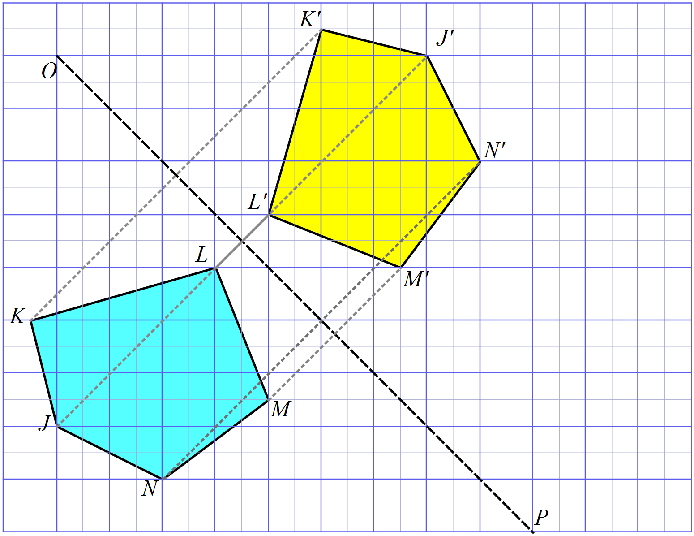(a) |  |  | 2
 | (b) Labels on the image above. |  |  | 1
 | (c) |  |  | 1
2. | 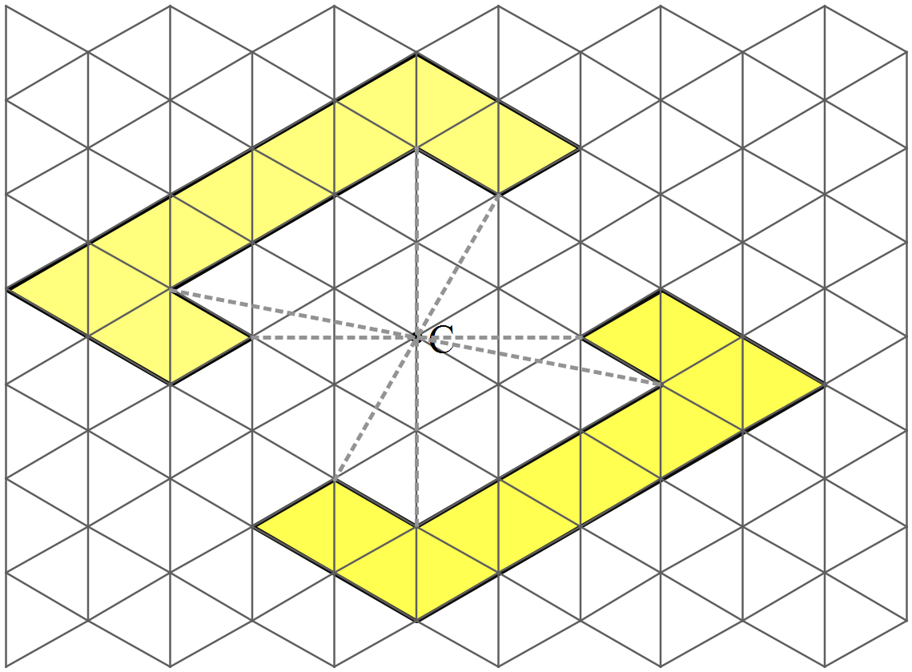(a)
3. | (a)  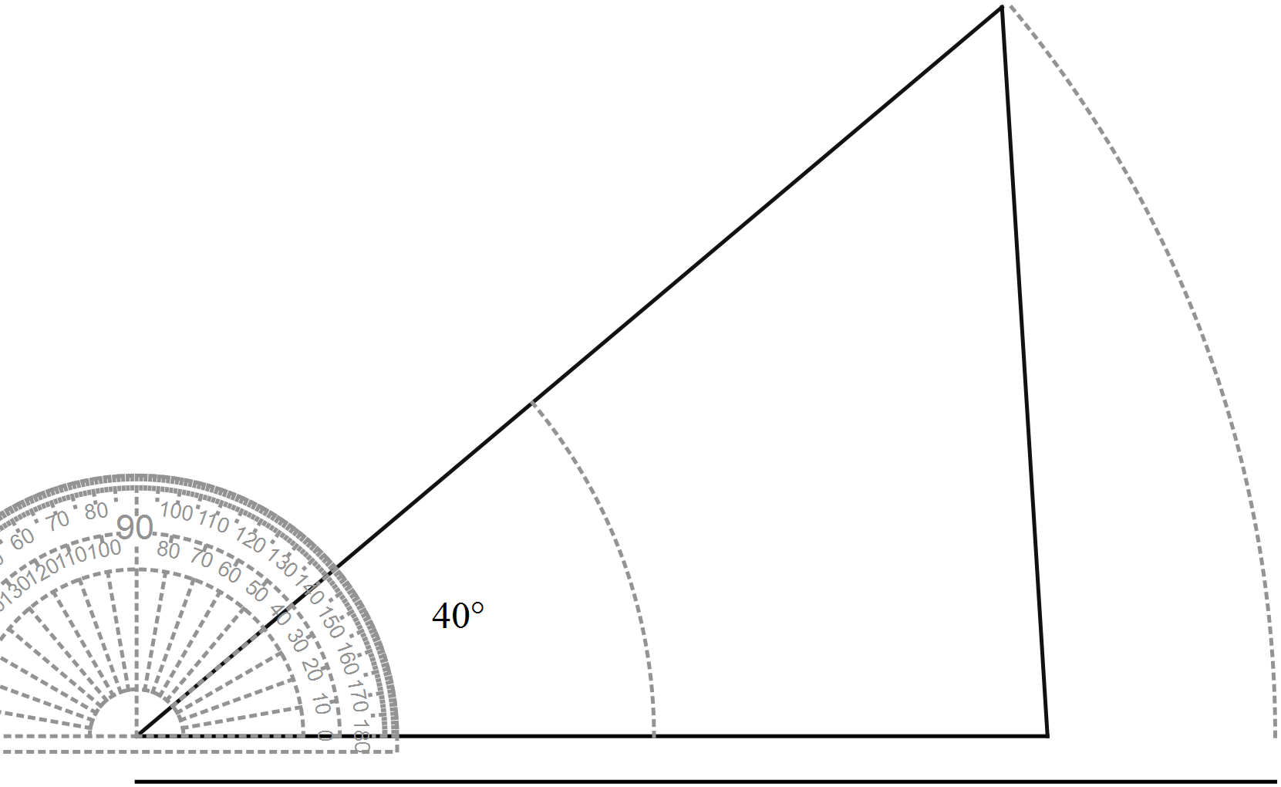 |  |  | 2
 | (b)  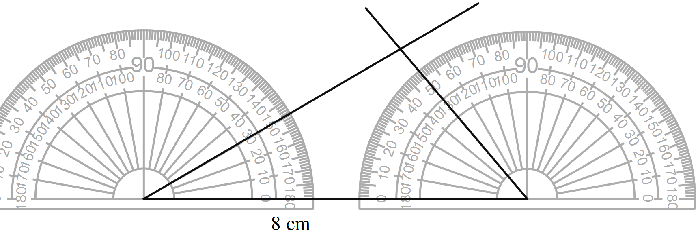 |  |  | 2
4. | (a)  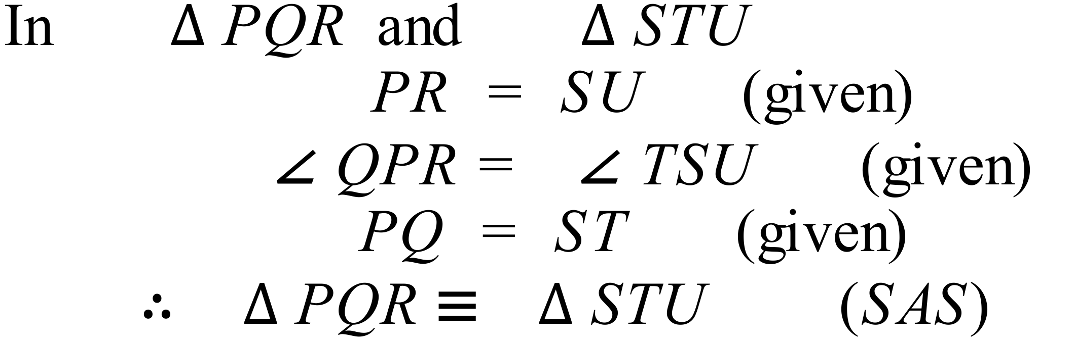 |  |  | 2
 | (b)  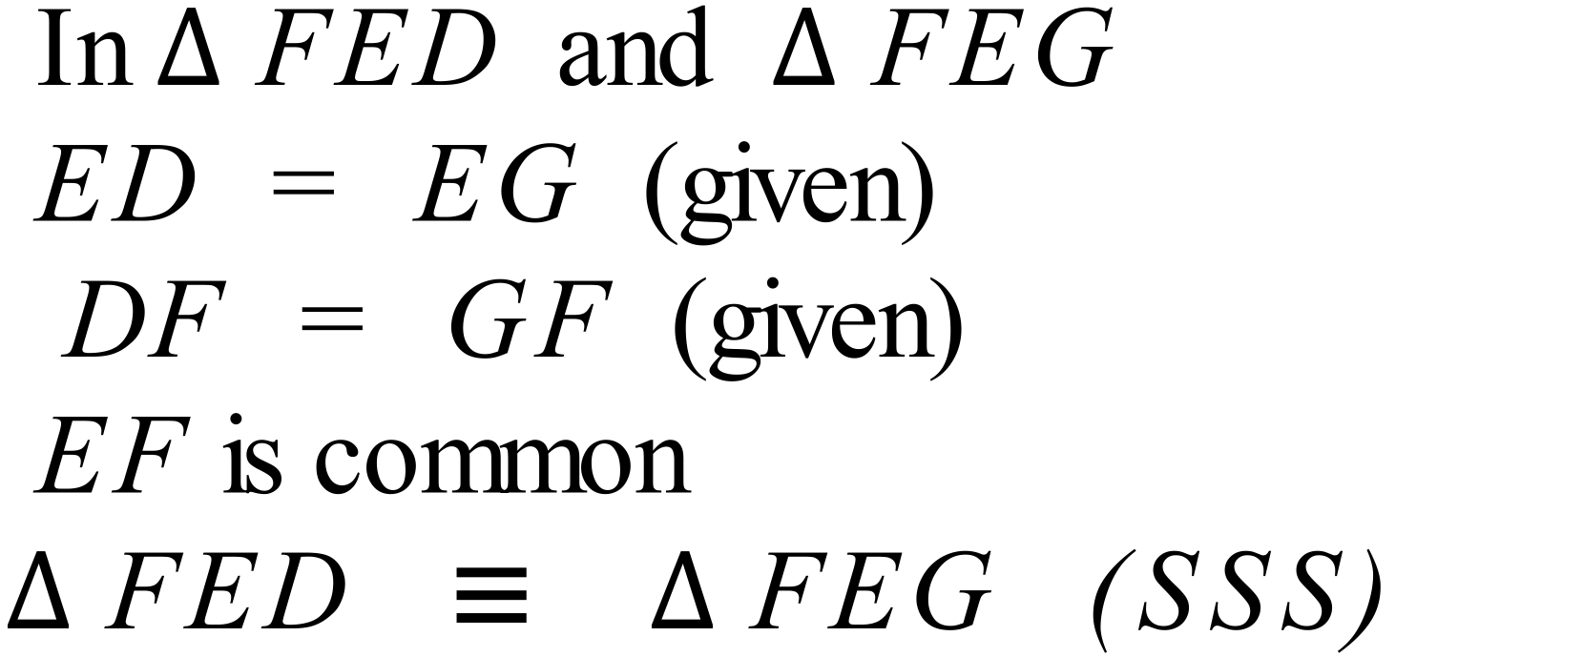 |  |  | 2
 | (c)  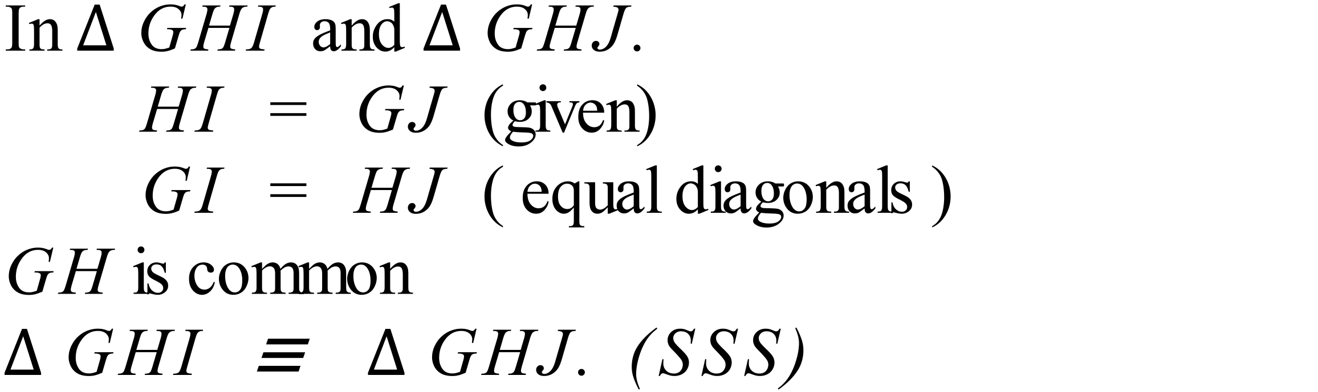 |  |  | 2

